ask 1. Imagine that you are preparing a project with your friend. You have found some interesting material for the presentation and you want to read this text to your friend. You have 1.5 minutes to read the text silently, then be ready to read it out aloud. You will not have more than 1.5 minutes to read it.

As soon as spring brings a new growth of bushes and berries, bears start feeding. They eat and eat. All through the spring and summer their feeding goes on. The bears build themselves up. They store food and fats that they will need in the fall when they start their long sleep.
As days grow shorter, and the temperature begins to fall, bears hunt for a sleeping place. It may be a shallow cave, or a deep crack between rocks. Some bears end up sleeping in hollow logs. Logs seem to be bears’ favourite places. Bears seem to choose small spaces. They can keep warmer in a cave that’s just large enough to hold them than in a larger cave. They often line their sleeping place with leaves and dried grass.
All through their winter naps, bears will not eat. Often they will sleep for 7 months, moving only now and then.

1DA193

Task 2. Study the advertisement.

You are going to study abroad for three months and want to find a swimming pool you could attend. You’d like to get more information about this swimming pool. In 1.5 minutes you are to ask five questions to find out the following:

1) location of the swimming pool  2) opening hours  3) sauna availability  4) price for 3 months  5) discounts for students  You have 20 seconds to ask each question. | 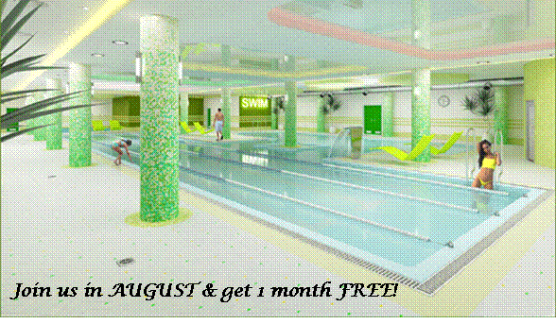

763BED

Task 3. Imagine that you are showing your photo album to your friend. Choose one photo to present to your friend.
You will have to start speaking in 1.5 minutes and will speak for not more than 2 minutes. You have to talk continuously. In your talk remember to speak about:

•€€€€when you took the photo
•€€€€what/who is in the photo
•€€€€what is happening
•€€€€why you took the photo
•€€€€why you decided to show the picture to your friend

Photo 1.  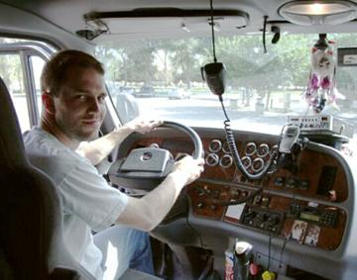 | Photo 2.   | Photo 3.  

50E710

Task 4. Study the two photographs. In 1.5 minutes be ready to compare and contrast the photographs:

•€€€give a brief description (action, location)
•€€€say what the pictures have in common
•€€€say in what way the pictures are different
•€€€say which kind of life you’d prefer for wild animals
•€€€explain why

You will speak for not more than 2 minutes. You have to talk continuously.

1.  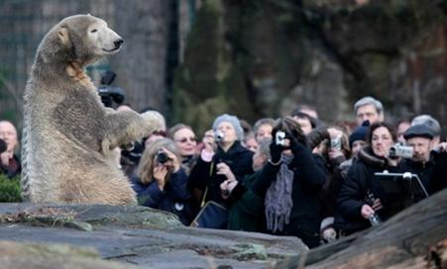 | 2.  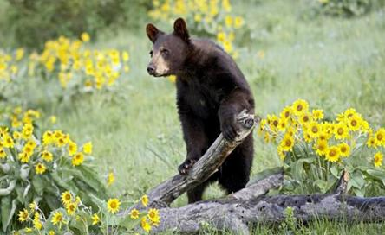

F3EDA4

Task 1. Imagine that you are preparing a project with your friend. You have found some interesting material for the presentation and you want to read this text to your friend. You have 1.5 minutes to read the text silently, then be ready to read it out aloud. You will not have more than 1.5 minutes to read it.

Many lands that had once been swamps were drained or filled in. There are different reasons why people drained swamplands. Some were drained to fight diseases caused by insects that lived in them. Because swamps were considered unpleasant places in which to live and harmful to health, many people thought that unless they were drained the land was worthless.
Other swamps were drained to make new land. As the population grew and more land was needed, people drained swamps or filled them to make room for more farms and factories, more roads and airports.
Few people thought that it might be harmful to get rid of swamps. As swamps disappeared, other things happened. There were both more floods and more droughts than before. There were also more fires, for swamps had acted as firebreaks. Hunters noticed that there was less wild game. Wild life that once lived in the swamps was dying out, because it had no place to live.

D445DD

Task 2. Study the advertisement.

You are going to visit Japan this summer and you'd like to have more information about the flights to Japan. In 1.5 minutes you are to ask five questions to find out the following:

1) departure dates  2) travel time  3) return ticket price  4) discounts for students  5) buying the ticket online  You have 20 seconds to ask each question. | 

46B097

Task 3. Imagine that while travelling during your holidays you took some photos. Choose one photo to present to your friend. You will have to start speaking in 1.5 minutes and will speak for not more than 2 minutes. You have to talk continuously. In your talk remember to speak about:
•€€€€€€when you took the photo
•€€€€€€what/who is in the photo
•€€€€€€what is happening
•€€€€€€why you took the photo
•€€€€€€why you decided to show the picture to your friend

Photo 1.  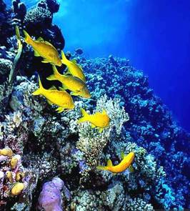 | Photo 2.  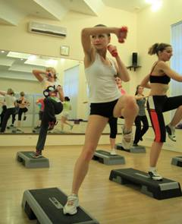 | Photo 3.  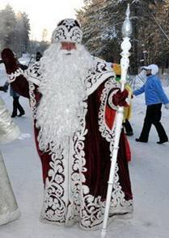

7DFD71

Task 4. Study the two photographs. In 1.5 minutes be ready to compare and contrast the photographs:

•€€€give a brief description (action, location)
•€€€say what the pictures have in common
•€€€say in what way the pictures are different
•€€€say which kind of life you’d prefer
•€€€explain why

You will speak for not more than 2 minutes. You have to talk continuously.

1.  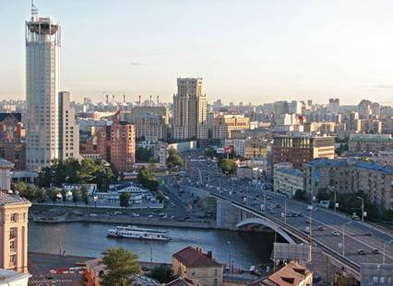 | 2.  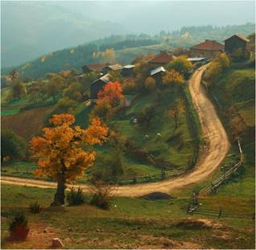

724360

Task 4. Study the two photographs. In 1.5 minutes be ready to compare and contrast the photographs:
· give a brief description of the photos (action, location)
· say what the pictures have in common
· say in what way the pictures are different
· say which of the activities presented in the pictures you’d prefer
· explain why
You will speak for not more than 2 minutes (12–15 sentences). You have to talk continuously.
1. | 2.
 | 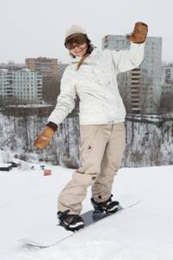

54CEFE

Task 3. Imagine that these are photos from you album. Choose one photo to present to your friend. You will have to start speaking in 1.5 minutes and will speak for not more than 2 minutes (12–15 sentences). In your talk remember to speak about:
· when you took the photo
· what/who is in the photo
· what is happening
· why you took the photo
· why you decided to show the picture to your friend
Photo 1.   | Photo 2.   | Photo 3.  
You have to talk continuously, starting with:
“I’ve chosen photo number …”.

ask 4. Study the two photographs. In 1.5 minutes be ready to compare and contrast the photographs:
· give a brief description of the photos (action, location)
· say what the pictures have in common
· say in what way the pictures are different
· say which of the celebrations in the pictures you like more
· explain why
You will speak for not more than 2 minutes (12–15 sentences). You have to talk continuously.
1. | 2.
 | 

03E9C4

Task 2. Study the advertisement.
You are considering starting breakdance lessons and now you’d like to get more information. In 1.5 minutes you are to ask five direct questions to find out about the following:
Welcome to our school of breakdance!

1) tuition fee
2) course location
3) duration of the course
4) special clothes
5) evening classes
You have 20 seconds to ask each question.

9CA8C8

Task 2. Study the advertisement.
You are considering buying the book and now you’d like to get more information. In 1.5 minutes you are to ask five direct questions to find out about the following:
A new Cooking Book from Julia Taylor!

1) if it’s a paperback edition
2) number of illustrations
3) vegetarian dishes
4) the price
5) audio version of the book
You have 20 seconds to ask each question.

EACEC6

Task 4. Study the two photographs. In 1.5 minutes be ready to compare and contrast the photographs:
· give a brief description of the photos (action, location)
· say what the pictures have in common
· say in what way the pictures are different
· say which of the leisure activities presented in the pictures you’d prefer
· explain why
You will speak for not more than 2 minutes (12–15 sentences). You have to talk continuously.
1. | 2.
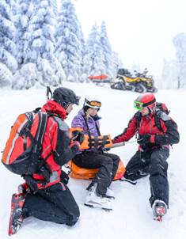 | 

4D4662

Task 3. Imagine that these are photos from you album. Choose one photo to present to your friend. You will have to start speaking in 1.5 minutes and will speak for not more than 2 minutes (12–15 sentences). In your talk remember to speak about:
· when you took the photo
· what/who is in the photo
· what is happening
· why you took the photo
· why you decided to show the picture to your friend
Photo 1.   | Photo 2.   | Photo 3.  
You have to talk continuously, starting with:
“I’ve chosen photo number …”.

D0D532

Task 2. Study the advertisement.
You are considering going on this sightseeing tour and now you’d like to get more information. In 1.5 minutes you are to ask five direct questions to find out the following:
London Bridges Sightseeing Tour!
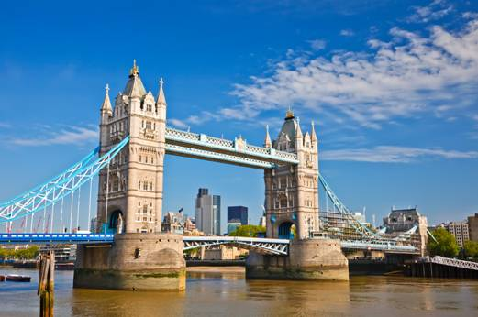
1) duration of the tour
2) the starting point
3) number of bridges you’ll visit
4) the price for a group of 10
5) discounts for students
You have 20 seconds to ask each question.

69C33C

Task 3. Imagine that these are photos from your album. Choose one photo to present to your friend. You will have to start speaking in 1.5 minutes and will speak for not more than 2 minutes (12–15 sentences). In your talk remember to speak about:
· when you took the photo
· what/who is in the photo
· what is happening
· why you took the photo
· why you decided to show the picture to your friend
Photo 1.   | Photo 2.   | Photo 3.  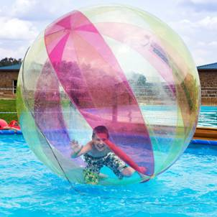
You have to talk continuously, starting with:
“I’ve chosen photo number …”.

9B1084

Task 2. Study the advertisement.
Make your life easier with our new kitchen unit!

You are considering buying the appliance and now you’d like to get more information. In 1.5 minutes you are to ask five direct questions to find out about the following:
1) price
2) if one can buy it online
3) number of functions
4) guarantee period
5) recipe book to go with the unit
You have 20 seconds to ask each question.

FEF840

Task 4. Study the two photographs. In 1.5 minutes be ready to compare and contrast the photographs:
· give a brief description of the photos (action, location)
· say what the pictures have in common
· say in what way the pictures are different
· say which of the ways of reading a book presented in the pictures you’d prefer
· explain why
You will speak for not more than 2 minutes (12–15 sentences). You have to talk continuously.
Photo 1.   | Photo 2.  

308AFF

Task 1. Imagine that you are preparing a project with your friend. You have found some interesting material for the presentation and you want to read this text to your friend. You have 1.5 minutes to read the text silently, then be ready to read it out aloud. You will not have more than 1.5 minutes to read it.

A hobby is an activity you enjoy doing, it is something of your choice, something unique to your taste and talent. A hobby can improve our well-being; it can give more meaning to our life. Just as physical exercise is important for the body, relaxation of the mind is also essential. In fact, studies reveal that people who cultivate themselves through such activities are less likely to suffer from anxieties, depression and other negative feelings. A hobby is the easiest way to restore your balance whenever you are over-worked or stressed. Since it is an activity of your choosing, it will always give you pleasure and help you to relax. Even if you indulge in your hobby for a short period of time, you still can feel the difference in your energy level and spirit. When you have a hobby, you will always find time for it.

F75BBB

[1] 2 [3] [4] [5]

Task 3. Imagine that these are photos from your photo album. Choose one photo to present to your friend. You will have to start speaking in 1.5 minutes and will speak for not more than 2 minutes
(12–15 sentences). In your talk remember to speak about:
· where and when the photo was taken
· what/who is in the photo
· what is happening
· why you keep the photo in your album
· why you decided to show the picture to your friend
Photo 1.  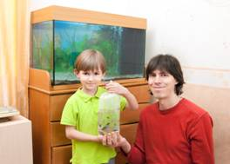 | Photo 2.  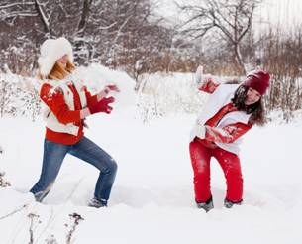 | Photo 3.  
You have to talk continuously, starting with: “I’ve chosen photo number …”

559EB1

Task 4. Study the two photographs. In 1.5 minutes be ready to compare and contrast the photographs:
· give a brief description of the photos (action, location)
· say what the pictures have in common
· say in what way the pictures are different
· say which of the ways of spending free time presented in the pictures you’d prefer
· explain why
You will speak for not more than 2 minutes (12–15 sentences). You have to talk continuously.
Photo 1.   | Photo 2.  

90C154

Task 1. Imagine that you are preparing a project with your friend. You have found some interesting material for the presentation and you want to read this text to your friend. You have 1.5 minutes to read the text silently, then be ready to read it out aloud. You will not have more than 1.5 minutes to read it.

The first maps were drawn by explorers to help them find their way home and show people where they had been. The maps showed the shape of the land, distances between places and special features such as caves and old trees. Nowadays, maps show the towns and villages, and the roads, railways, rivers and mountains. Symbols are used to show all the different things on a map and there is a key to explain what the symbols stand for.
Over the centuries, people explored most of the Earth and put together the map of the world we use today. Maps of the world or large areas are often either “political” or “physical”. The political map shows territorial borders. The purpose of the physical map is to show features of geography such as mountains, soil type or land use including roads, railroads and buildings.

0D7699

Task 2. Study the advertisement.
Visit our new fitness club!

You are considering visiting the fitness club and now you’d like
to get more information. In
1.5 minutes you are to ask five direct questions to find out about the following:
1) location
2) opening hours
3) price of the season ticket
4) if individual sessions are possible
5) swimming pool
You have 20 seconds to ask each question.

BEE49E

Task 1. Imagine that you are preparing a project with your friend. You have found some interesting material for the presentation and you want to read this text to your friend. You have 1.5 minutes to read the text silently, then be ready to read it out aloud. You will not have more than 1.5 minutes to read it.

People have enjoyed sports for thousands of years. Children, men and women play sports both for pleasure and for challenge. Every sport involves physical skill. Every sport has a set of rules that the players of the sport follow. In some sports one person competes against other individuals. Examples of these sports include boxing, tennis and so on. In many games one team competes against the other team.
People can go in for winter and summer sports. Summer sports are typical for warmer countries. Those who live in regions that experience cold winters have long enjoyed ice skating, skiing, and sledding. These activities have grown immensely in popularity over the years. Today thousands of resorts cater to the winter tourist trade, and millions of people each year take winter sports vacations.

1F0D90

Task 2. Study the advertisement.
Best presents in our flower boutique!

You are considering buying some flowers and now you’d like to get more information. In 1.5 minutes you are to ask five direct questions to find out about the following:
1) location
2) opening hours
3) kinds of flowers in stock
4) if they sell pot plants
5) discounts for big orders
You have 20 seconds to ask each question.

DE8790

Task 4. Study the two photographs. In 1.5 minutes be ready to compare and contrast the photographs:
· give a brief description of the photos (action, location)
· say what the pictures have in common
· say in what way the pictures are different
· say which of the ways of taking care of your health presented in the pictures you’d prefer
· explain why
You will speak for not more than 2 minutes (12–15 sentences). You have to talk continuously.
Photo 1.   | Photo 2.  

32C49F

Task 3. Imagine that these are photos from your photo album. Choose one photo to present to your friend. You will have to start speaking in 1.5 minutes and will speak for not more than 2 minutes
(12–15 sentences). In your talk remember to speak about:
· where and when the photo was taken
· what/who is in the photo
· what is happening
· why you keep the photo in your album
· why you decided to show the picture to your friend
Photo 1.   | Photo 2.  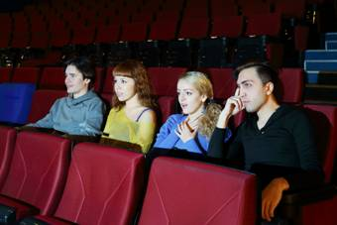 | Photo 3.  
You have to talk continuously, starting with: “I’ve chosen photo number …”

750835

Task 3. Imagine that these are photos from your photo album. Choose one photo to present to your friend. You will have to start speaking in 1.5 minutes and will speak for not more than 2 minutes
(12–15 sentences). In your talk remember to speak about:
· where and when the photo was taken
· what/who is in the photo
· what is happening
· why you keep the photo in your album
· why you decided to show the picture to your friend
Photo 1.   | Photo 2.  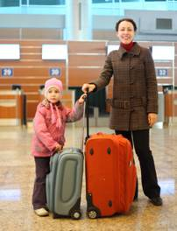 | Photo 3.  
You have to talk continuously, starting with: “I’ve chosen photo number …”

101583

 Task 4. Study the two photographs. In 1.5 minutes be ready to compare and contrast the photographs:
· give a brief description of the photos (action, location)
· say what the pictures have in common
· say in what way the pictures are different
· say which of the ways of spending your free time presented in the pictures you’d prefer
· explain why
You will speak for not more than 2 minutes (12–15 sentences). You have to talk continuously.
Photo 1.   | Photo 2.  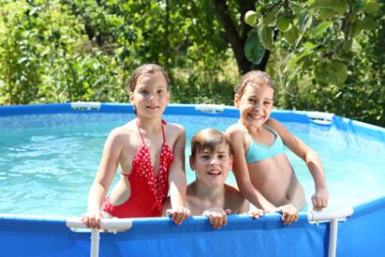

45F542

[1] [2] 3 [4] [5]

Task 3. These are photos from your photo album. Choose one photo to describe to your friend.
You will have to start speaking in 1.5 minutes and will speak for not more than 2 minutes
(12–15 sentences). In your talk remember to speak about:
· where and when the photo was taken
· what/who is in the photo
· what is happening
· why you keep the photo in your album
· why you decided to show the picture to your friend
Photo 1.  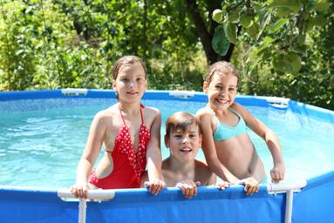 | Photo 2.  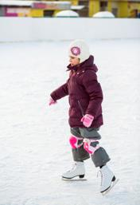 | Photo 3.  
You have to talk continuously, starting with: “I’ve chosen photo number …”

5DC747

Task 4. Study the two photographs. In 1.5 minutes be ready to compare and contrast the photographs:
· give a brief description of the photos (action, location)
· say what the pictures have in common
· say in what way the pictures are different
· say which of the ways of spending free time presented in the pictures you’d prefer
· explain why
You will speak for not more than 2 minutes (12–15 sentences). You have to talk continuously.
Photo 1.   | Photo 2.  

62D64E

 Task 3. These are photos from your photo album. Choose one photo to describe to your friend.
You will have to start speaking in 1.5 minutes and will speak for not more than 2 minutes
(12–15 sentences). In your talk remember to speak about:
· where and when the photo was taken
· what/who is in the photo
· what is happening
· why you keep the photo in your album
· why you decided to show the picture to your friend
Photo 1.   | Photo 2.   | Photo 3.  
You have to talk continuously, starting with: “I’ve chosen photo number …”

427DF0

 Task 3. These are photos from your photo album. Choose one photo to describe to your friend.
You will have to start speaking in 1.5 minutes and will speak for not more than 2 minutes
(12–15 sentences). In your talk remember to speak about:
· where and when the photo was taken
· what/who is in the photo
· what is happening
· why you keep the photo in your album
· why you decided to show the picture to your friend
Photo 1.   | Photo 2.   | Photo 3.  
You have to talk continuously, starting with: “I’ve chosen photo number …”

6453FF

Task 4. Study the two photographs. In 1.5 minutes be ready to compare and contrast the photographs:
· give a brief description of the photos (action, location)
· say what the pictures have in common
· say in what way the pictures are different
· say which of the ways of spending free time presented in the pictures you’d prefer
· explain why
You will speak for not more than 2 minutes (12–15 sentences). You have to talk continuously.
Photo 1.  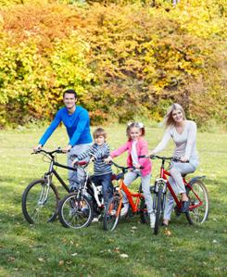 | Photo 2.  

1F2F04

Task 3. These are photos from your photo album. Choose one photo to describe to your friend.
You will have to start speaking in 1.5 minutes and will speak for not more than 2 minutes
(12–15 sentences). In your talk remember to speak about:
· where and when the photo was taken
· what/who is in the photo
· what is happening
· why you keep the photo in your album
· why you decided to show the picture to your friend
Photo 1.   | Photo 2.   | Photo 3.  
You have to talk continuously, starting with: “I’ve chosen photo number …”

CE4777

Task 4. Study the two photographs. In 1.5 minutes be ready to compare and contrast the photographs:
· give a brief description of the photos (action, location)
· say what the pictures have in common
· say in what way the pictures are different
· say which of the places presented in the pictures you’d prefer to live in
· explain why
You will speak for not more than 2 minutes (12–15 sentences). You have to talk continuously.
Photo 1.  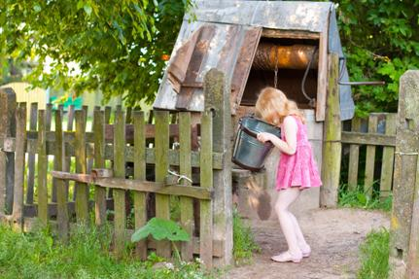 | Photo 2.  

C0257B

Task 4. Study the two photographs. In 1.5 minutes be ready to compare and contrast the photographs:
· give a brief description of the photos (action, location)
· say what the pictures have in common
· say in what way the pictures are different
· say which of the seasons presented in the pictures you’d prefer
· explain why
You will speak for not more than 2 minutes (12–15 sentences). You have to talk continuously.
Photo 1.   | Photo 2.  

51D810

Task 4. Study the two photographs. In 1.5 minutes be ready to compare and contrast the photographs:
· give a brief description of the photos (action, location)
· say what the pictures have in common
· say in what way the pictures are different
· say which of the foods presented in the pictures you’d prefer
· explain why
You will speak for not more than 2 minutes (12–15 sentences). You have to talk continuously.
Photo 1.   | Photo 2.  

60512E

Task 3. These are photos from your photo album. Choose one photo to describe to your friend.
You will have to start speaking in 1.5 minutes and will speak for not more than 2 minutes
(12–15 sentences). In your talk remember to speak about:
· where and when the photo was taken
· what/who is in the photo
· what is happening
· why you keep the photo in your album
· why you decided to show the picture to your friend
Photo 1.  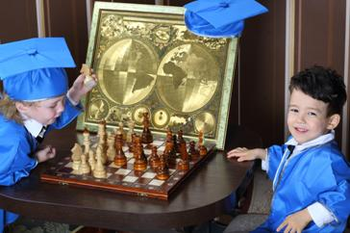 | Photo 2.   | Photo 3.  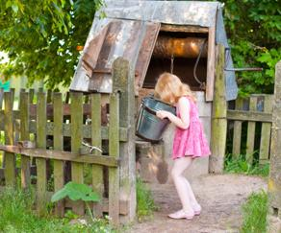
You have to talk continuously, starting with: “I’ve chosen photo number …”

3A5426

[1] [2] [3] 4 [5]

Task 2. Study the advertisement.
You are considering celebrating your birthday party in this café and now you’d like to get more information. In 1.5 minutes you are to ask five direct questions to find out about the following:

Birthday parties for all ages!

1) location
2) types of food served
3) vegetarian dishes
4) dancing floor
5) group discounts

You have 20 seconds to ask each question.

04E7DE

 Task 2. Study the advertisement.
You are considering going on a sightseeing tour and now you’d like to get more information. In 1.5 minutes you are to ask five direct questions to find out about the following:

Enjoy our hop-on-hop-off sightseeing tour!
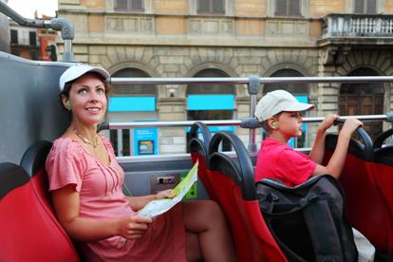
1) operation hours
2) starting point
3) tourist attractions to see
4) price for one person
5) group discounts

You have 20 seconds to ask each question.

903CD8

Task 2. Study the advertisement.
You are considering having a holiday at this resort and now you’d like to get more information. In 1.5 minutes you are to ask five direct questions to find out about the following:

Lots of fun in the sun!
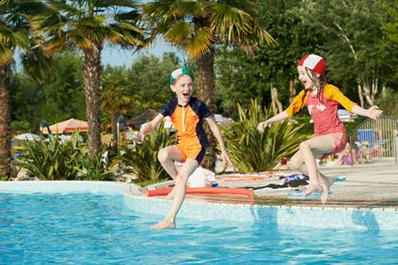
1) location
2) departure dates
3) single rooms
4) sports facilities
5) price for two weeks for one

You have 20 seconds to ask each question.

8A19DC

Task 2. Study the advertisement.
You are considering having a seaside holiday and now you’d like to get more information. In 1.5 minutes you are to ask five direct questions to find out about the following:

Holiday by the sea for the whole family!

1) location
2) transportation
3) sports facilities
4) price for a week for one person
5) family discounts

You have 20 seconds to ask each question.

4ABDA0

Task 2. Study the advertisement.
You are considering having a holiday and now you’d like to get more information. In 1.5 minutes you are to ask five direct questions to find out about the following:
Enjoy a quiet holiday by the lake!
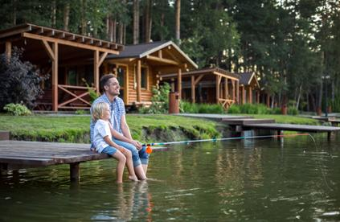

1) location
2) accommodation
3) fishing
4) price for a week for one
5) group discounts

You have 20 seconds to ask each question.

0070A2

Task 3. These are photos from your photo album. Choose one photo to describe to your friend.
You will have to start speaking in 1.5 minutes and will speak for not more than 2 minutes
(12–15 sentences). In your talk remember to speak about:
· where and when the photo was taken
· what/who is in the photo
· what is happening
· why you keep the photo in your album
· why you decided to show the picture to your friend
Photo 1.   | Photo 2.  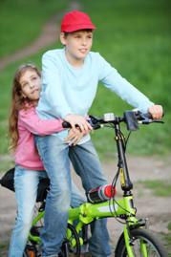 | Photo 3.  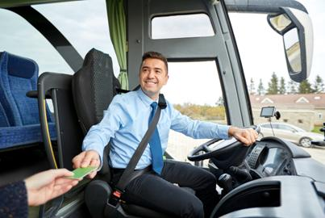
You have to talk continuously, starting with: “I’ve chosen photo number …”

10C591

Task 2. Study the advertisement.
You are considering using the clinic and now you’d like to get more information. In 1.5 minutes you are to ask five direct questions to find out about the following:

Our vet clinic will take care of your pet!

1) location
2) opening hours
3) transportation
4) kinds of animals treated
5) if home visits are possible

You have 20 seconds to ask each question.

2A1F95

[1] [2] [3] [4] 5

