ОГБПОУ «Рославльский медицинский техникум»

Доклад по английскому языку на тему:
«ФАКТЫ О МЕДИЦИНЕ»

Власенко Анастасия
21ФМКа
специальность 33.02.01 Фармация

«FACTS ABOUT MEDICINE»

Anastasiya Vlasenko

Рославль
2020
My name is Anastasiya Vlasenko. I study at a medical college. I am a second – year student of Pharmacy Department.
I think medicine is interesting. I have some medicine facts which you may find useful.
- The tribe “Maya” reliably knew that “Moneses grandiflora” (Pic. 1) kills absolutely all microbes. Modern medicine can only reduce their number.

Pic. 1. Moneses grandiflora

- Until the middle of the 19th century, there had practically been no dentists in Europe specializing exclusively in the treatment of teeth and toothache. The functions of dentists were performed by general practitioners and hairdressers (practicing exclusively tooth extraction). Today the situation is different (Pic. 2).

Pic. 2. At the dentist’s
- The most "bloody" (in the literal sense of the word) in the history of medicine surgical operations took place in 1970 in the USA. During its implementation, a patient with a diagnosis of “hemophilia” required 1080 liters of blood for transfusion.
- With the weekly use of five walnuts, life expectancy increases by seven years. This interesting fact was established by California scientists. The composition of walnuts includes substances that protect the heart and blood vessels from cholesterol.
- Medical statistics indicate an interesting unusual fact: on Monday, 25% more than usual back injuries happen and 33% more heart attacks.
- In the XIX century, after the start of industrial production of electricity, an interesting application in medicine was found. Electric beds and belts went on sale, the use of which, according to the creators, helped to cure men of impotence. The action of these instruments was to shock the patient.
- In Turkey, for the treatment of psoriasis, a patient is immersed in a bathtub filled with live fish (Pic. 3). It is believed that fish absorbs exfoliated skin.

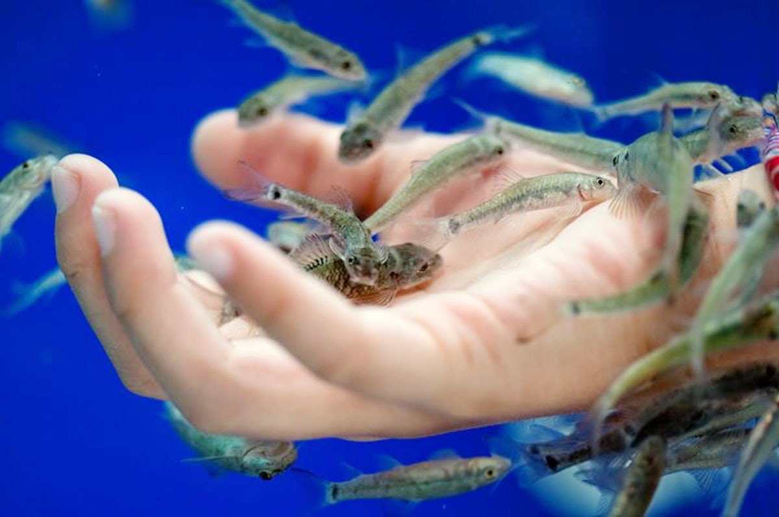
Pic. 3. Treatment

- It is a known fact about the health of US residents that Americans are prone to obesity. Taking it into account, the Alabama Health Insurance Board decided to oblige obsolete civil servants to deduct $ 25 per month from their wages, thereby stimulating them to reduce body weight. The deducted money is sent to pay for medical insurance that is free for employees of state structures.
- In medicine a gall bladder is examined as other organs of a human. Stones in a gall bladder (Pic. 4) is a pathological disease. In 2002, surgeons in Romania set an interesting record by removing 831 stones from the patient’s gall bladder.

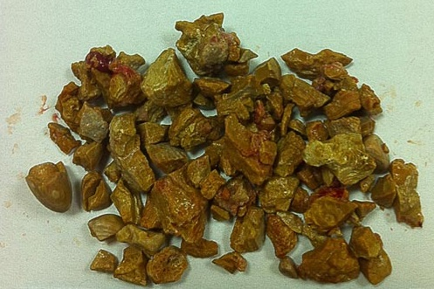
Pic. 4. Stones from a gall bladder

- K. Kilner from Zimbabwe had to eat most of the pills. It amounts almost 600 thousand for just 21 years of his life.
- Record cardiac arrest for 4 hours happened to a fisherman in Norway. Falling into the water in winter, he experienced a decrease in body temperature to 24 °C. He was saved by connecting to a cardiopulmonary bypass device.
- In Victorian England, alternative means of medicine were popular, including hydrotherapy. One of the sold remedies was a rocking bath designed in such a way that the person inside could move it and get the effect of sea waves (Pic. 5).

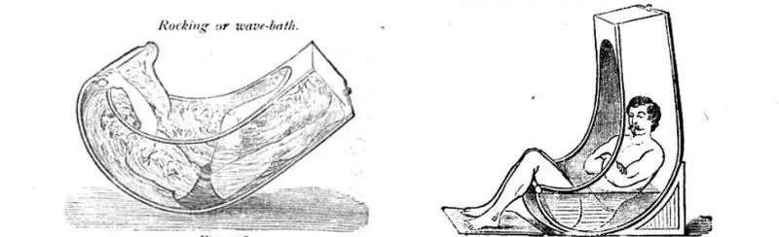
Pic. 5. A rocking water-bath
- An electric stingray is a sea fish which has a pair of electric organs (Pic. 6). The ability of electric stingrays to discharge the stiffness of their victims was used by the ancient Greeks for medical purposes. It helped to relieve pain during operations or childbirth.

Pic. 6. An electric stingray

- Blood is most often taken from the ring finger (Pic. 7) because, in comparison with the index and middle fingers, it is less used in work. The skin on it is thinner, and the puncture is less painful. The little finger, like the thumb, is not used to protect against any infection. In case an infection is brought through them, it can quickly spread to the whole arm.

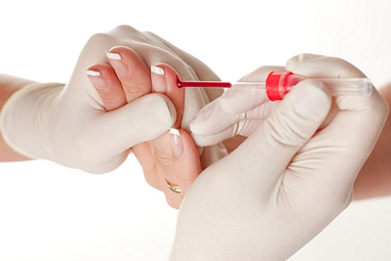
Pic. 7. Blood is being taken
- In XVI – XVIII centuries in Europe, special plague doctors were hired to treat plague sufferers who wore a protective set of leather cloaks, gloves, boots and a hat. The most noticeable detail of their costume was a bird-like mask (Pic. 8). Substances with strong odors were laid in it - dried flowers and herbs, spices, camphor or a sponge with vinegar, since it was believed that the plague was transmitted through bad "miasms" that should be drowned out.

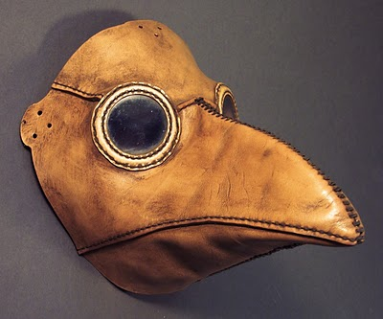
Pic 8. The mask of a plague doctor

There are a lot of interesting facts that you can find in medicine.

СПИСОК ИСПОЛЬЗОВАННОЙ ЛИТЕРАТУРЫ
- Сбойчаков В. Б. Микробиология с основами эпидемиологии и методами микробиологических исследований / В. Б. Сбойчатов. – М.: СпецЛит, 2011 – 400 с.
- Музей фактов. Интересные факты о медицине. – Режим доступа: http://
- Qwizz. Удивительное в медицине. – Режим доступа: https://

