
Министерство образования и науки Республики Татарстан
Государственное автономное профессиональное образовательное учреждение
«Альметьевский политехнический техникум»

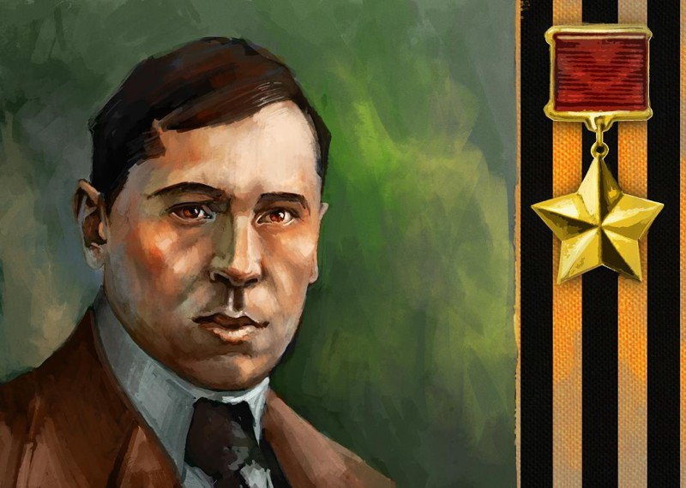

MUSA JALIL, A POET AND А HERO.

2018
Абдрахманова Р.Я. А party devoted to Musa Jalil, a poet and а hero. Методическое пособие па английскому языку для преподавателей: ГАПОУ «Альметьевский политехнический техникум», г. Альметьевск, 2018

Teacher: Dear students, teachers and guests! We’ve gathered here today to say that we are against war and we’ll do our best to preserve peace. Seventy one years have passed since the end of Great Patriotic War. We will never forget that these enormities bring people nothing but fear, humiliation and death. We’ll mourn the dead and pay all those who fought on the frontlines and those who selflessly toiled in the rear, the debt of gratitude of those who they saved. The world owed “great human thanks” to the 26.6 million Soviet citizens killed in the war.
Student 1: The Second World War caught up 61 countries and almost 80 percent of the Earth’s population in its inferno. This hurricane of fire blazed a trail of destruction not only across Europe but also across Asia and Africa. It reached all the way to Novaya Zemlya and Alaska, to the frontiers of Egypt and Australia.
But the most ruthless and decisive events- the events that determined the drama and the outcome of this inhuman war- unfolded on the territory of the Soviet Union. The Nazis counted on rapid enslavement of our people. Their intension was to destroy our country. Their plans failed.
Student 2: We are proud of the fact that almost 200,000 of our countrymen- people born in Tatarstan- were awarded military orders and medals for courage and bravery that over 200 daring sons and daughters of the Tatar people bear the title of Hero of the Soviet Union. Musa Jalil is the only poet of the Soviet Union’s multinational literature who has been awarded two of the highest decorations: Hero of he Soviet Union for personal courage and performance of duty, and the Lenin Prize for his cycle “The Moabit Notebooks”.
Student 3: Musa Jalil projects the image of a poet of courage. His name has become the symbol of courage, heroism and unbounded service to his country. The poet’s great feat was prepared for the whole of his life. Musa was born on the 2nd(15th) of February 1906 . His place of birth is the small Tatar village Mustafino in the Orenburg steppes. From childhood he knew what poverty and hunger meant. In 1921, when a severe draught hit the steppe lands, he left home so the family would have one hungry mouth less to feed and became a vagrant in the city of Orenburg. He slept in the streets, ate what he picked up in the marketplace and even stole to keep from starving, as Jalil admitted years later in his autobiography. Soviet government enabled him to get an education. In 1921 the 15-year-old Musa wrote a poem. He took the motto of the Paris Communards: “We will die but we will not be slaves” as an epigraph of the poem.
“We are strong; we will not lose our bearings.
There is none can bar our onward tread.
We are many, to the bright goal tracking.
We cannot and will not be misled.
Without fear we’ll close head on in battle,
Every raging tempest we will brave.
Even if for some the struggle’s fatal
None of us will ever be a slave.”
Twenty years later a prisoner in a fascist prison Moabit, Musa Jalil wrote lines in his hand-made notebook that are the direct continuation of his poem:
“Brave in battle you must be, djigit,
Hope in battle never leaves the brave.
Freedom goes with courage, they are granite,
If you have no courage you are a slave!”
Student 4: His poetry was like him. Impulsive and passionate believing implicitly in the just cause of socialism, hostile to all the trash surviving from pre-revolutionary times, it was at the same time kindly, responsive, tender. He wrote lyrical poems, poems that were of a publicist nature, poems for children, satirical poems. Before the war Jalil was a well-known poet, the head of the writer’s organization of the Tatar Republic. His poems were studied at schools.
Student 5: Musa Jalil left Kazan for the front early in 1942. He was a member of war newspaper “Courage”. He served in the Second Udarnaya Army in Volkhov Front as a senior political leader. In June 1942, the badly wounded poet was taken prisoner. After months in concentration camps he was transferred to Deblin, a fortress in Poland. There he met the countrymen. He met people he could trust and they formed a resistance group together. In August 1943, fascists learnt about the group’s plans. Musa Jalil and his comrades were seized. There followed days and nights of interrogation and torture. But the poet didn’t give in. He continued his fight against fascism. He had only his poetry for a weapon. Much has been written about horrors of fascist prisons.
Student 6: In 1946, N.Teregulov, a former prisoner-of-war, brought a slim pad to the Union of Writers of the Tatar Republic. Closely written in it there were 60 of Jalil’s poems. A year later, the Belgian patriotic Andre Timmermans, who had shared a cell with the poet, sent another notebook with Jalil’s poems to Kazan. The poems in those notebooks have since become widely known as “The Moabit Notebooks”.
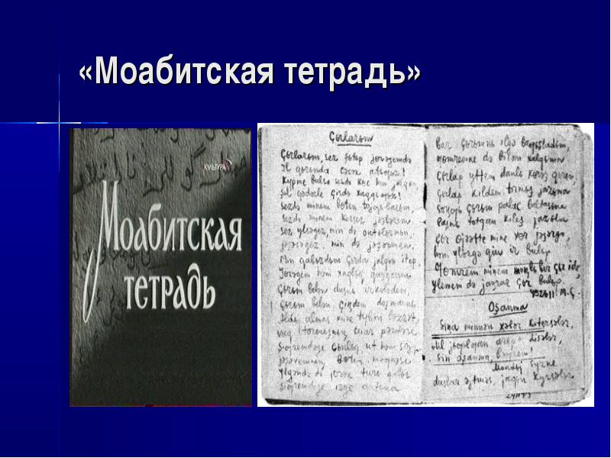
It took several years to trace step by step the path traversed by the poet through the death camps and to learn the details of his exploit. Every line of the Moabit cycle has been paid for with the highest price-the sacrifice of blood and life. “The Moabit Notebooks of Musa Jalil are one of those inimitable, glaringly truthful historic documents. They contain few day-to-day details. There are practically no particulars about the prison cell of the sufferings and humiliation to which prisoners were subjected. The poems are concrete in a totally different sense. Their concreteness lies in their emotional and psychological impact. The poems are remarkable for their genuine culture, heir style and profoundly national character. They show the poet’s heroism.
Student 7: Look at this picture “Before the verdict” by the Tatar artist Kharis Abdrakhmanovich Yakubov.

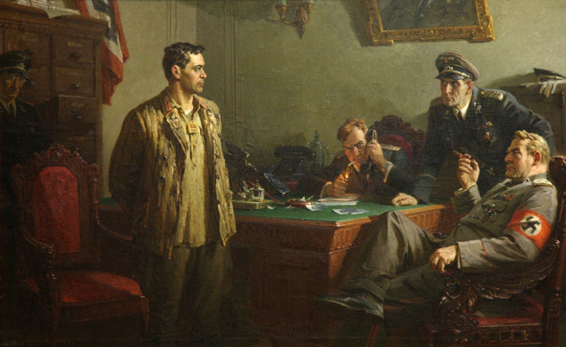

He made the character of the national hero. Musa Jalil looks like a man fearless and confident to his ideas.
“I won’t kneel, executioner, before you
Though I’m a prisoner of yours, I’m a prison slave of yours.
My hour comes- I’ll die. But know I’m going to die, standing up,
Even though you’ll cut my head away, villain”.
Musa Jalil meets his sentence with such iron endurance: any muscles on his face doesn’t shake, any movement doesn’t give out his heartache. His life is a model of service to our country and of great heroism.
Student 8: The courage of Musa Jalil was perpetuated in many monuments.
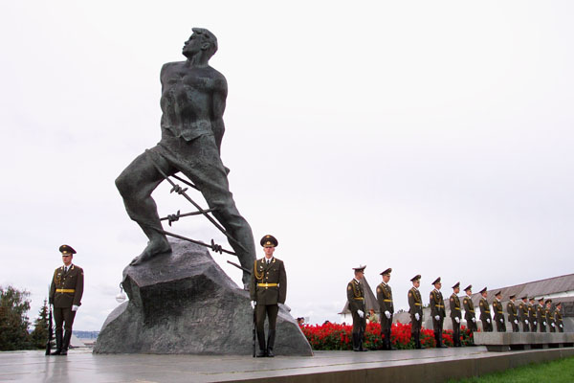
In Kazan, there is a monument to our great countryman Musa Jalil. It is near The Spasskaya Tower of the Kremlin. The poet is standing with his feet tied with a were, his hands tied behind his back. He is looking into the future. Musa Jalil loved people, loved life and loved the nature of his Motherland. He gave his life to save all there from fascism. Every day we walk along the monument to Musa Jalil in Lenin Street in Almetyevsk.

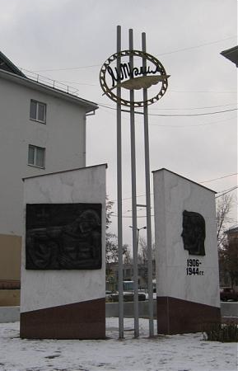
Student 9: Musa Jalil is among us to this day. Streets, theatres, ships bear his name. A new town in oil bearing region of the Tatar Republic, Jalil is one of the beautiful towns there. It was
founded in 1964
. 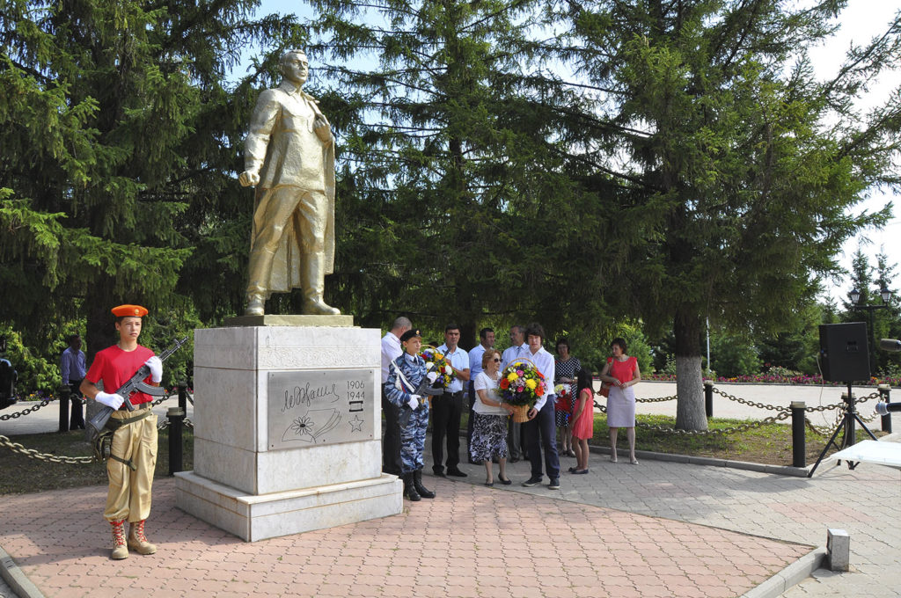
It was named in honour of the great Tatar poet Musa Jalil.
“My life s told as a song among people
And my death will sound like a song of the fight”.
The main street in Naberezhnye Chelny in Tatarstan a new street in Berkatit Township on the Baikal-Amur Railway line and one of the highest peaks on the Antarctic continent have been named after Musa Jalil.
“Our deadly foes have put him into shackles,
But nothing that they did could break his will.
Though in captivity, the poet’s message,
No force can manacle, no force can kill…
The free born poem of the captive poet,
You, my winged one, hasten to our home.
And though in foreign country I should perish
My song will live undying mongst my own!
Teacher: Dear students! History teaches us that states and peoples must do everything they cannot let their eyes close to the emergence of new lethal doctrines, to anything that can become fertile soil for new threats. Faced with the real threat of terrorism today, we must, therefore, remain faithful to the memory of our great grandparents, grandparents. It is our duty to defend a world order based on security and justice.
Thank you for coming and taking an active part in our party.

.

