PROJECT
« CHARITY ORGANIZATION»

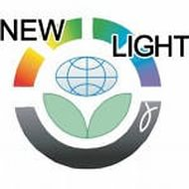

Guschin N.Y.
My teacher: Romenskaya S.Y.
Charity is quite popular nowadays. People have become more open and kindhearted. On the whole, charity means voluntary giving of help to whose are in need.
My name is Nikita. I am 14. I live in the city Izhevsk. There is organisation «New Light». I am a volunteer this charity organisation.

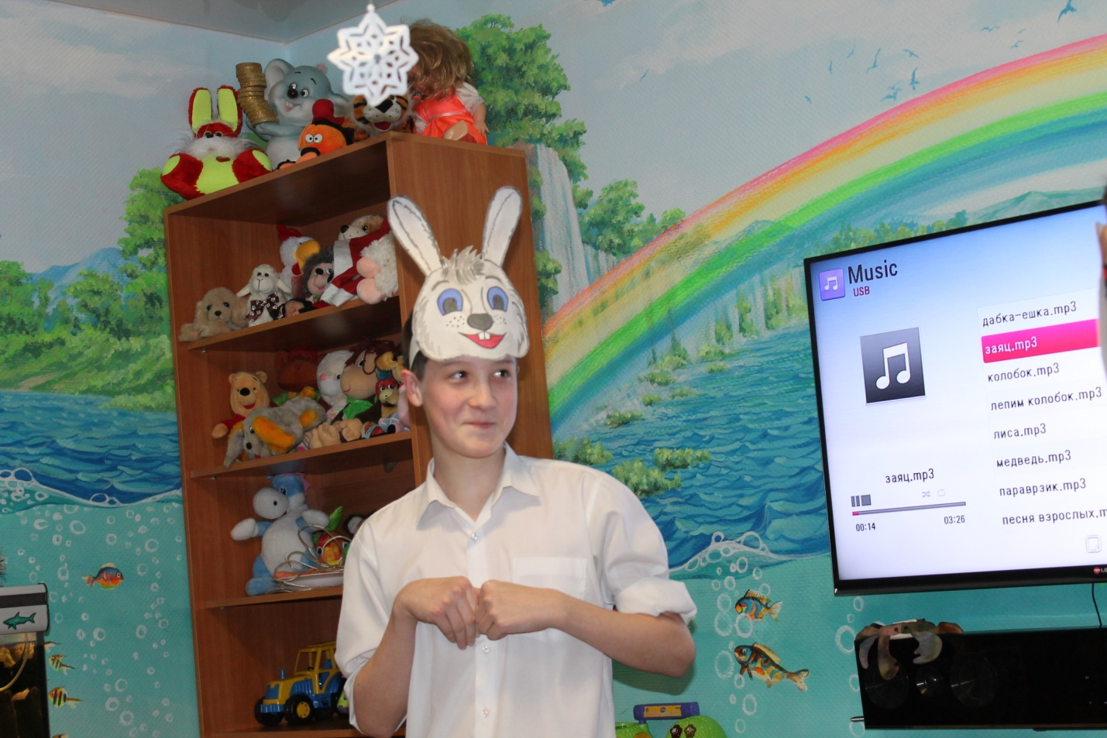
This is charity organization to support homeless and needy child more than that cares drug addict.
Besides “New Light” helps people with disability, to provide poor people food, money and clothes.
Rustam Karimov is leader this organisation. 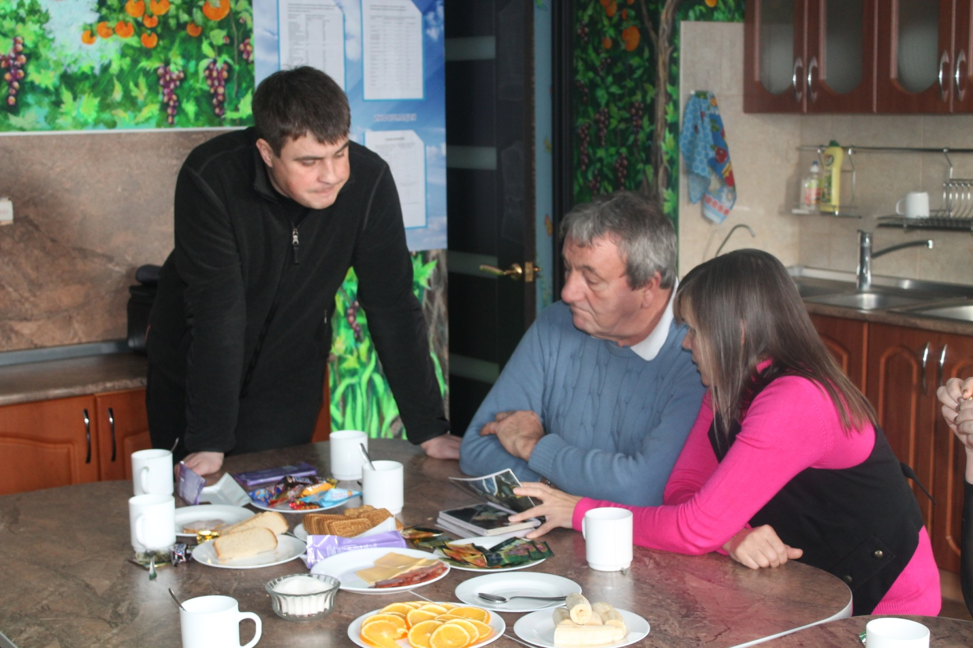
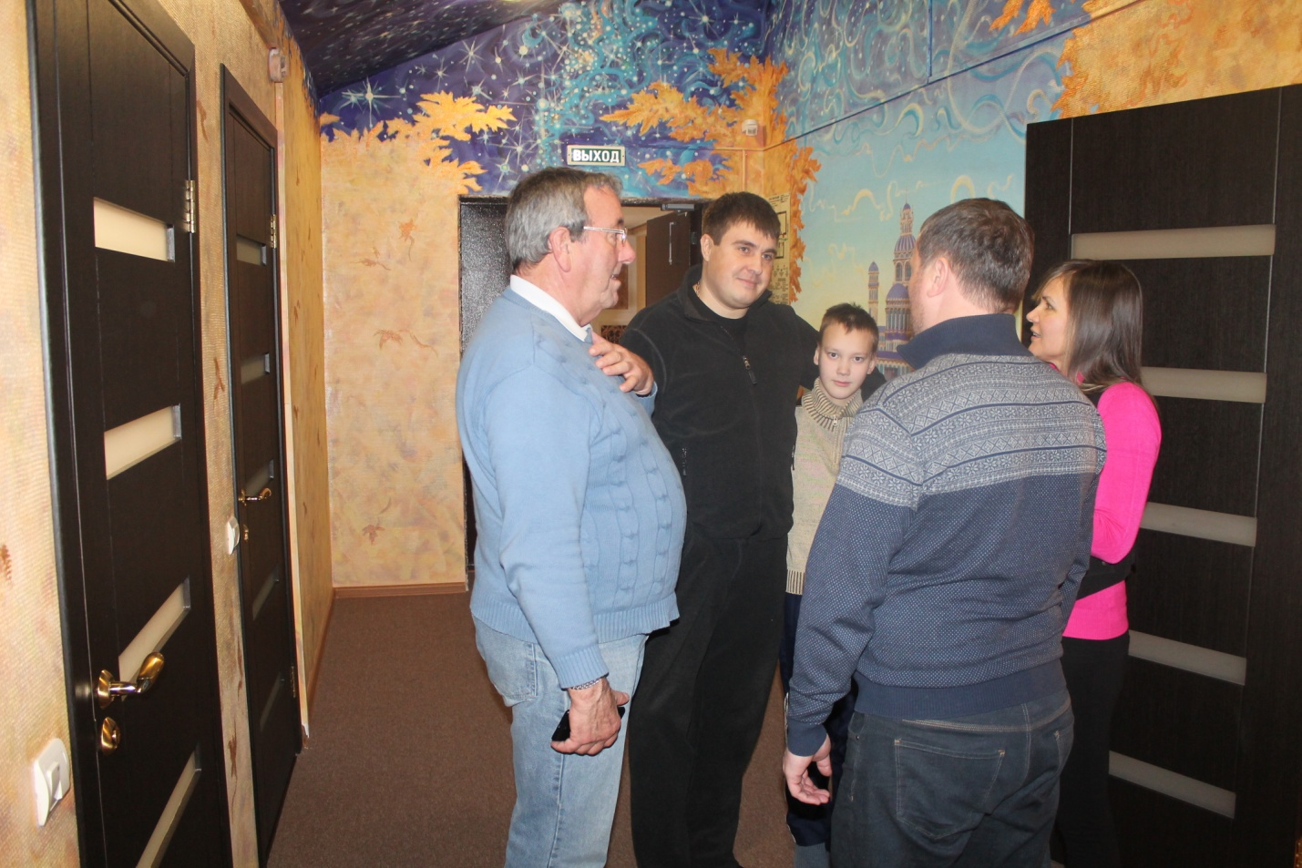

Spectrum of activity of the organization "New Light":

- Rehabilitation of people addicted to drugs and alcohol.
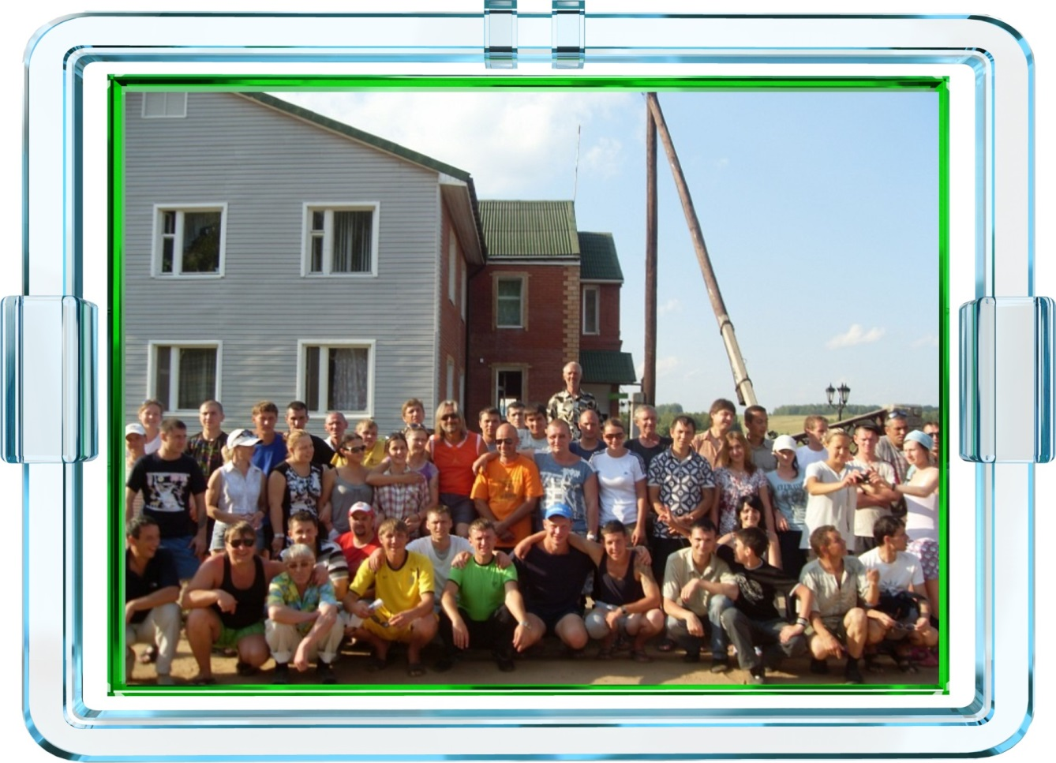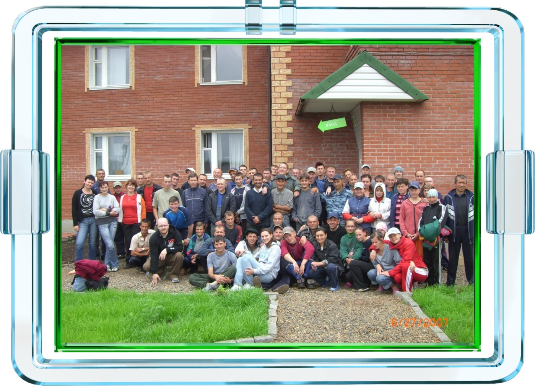

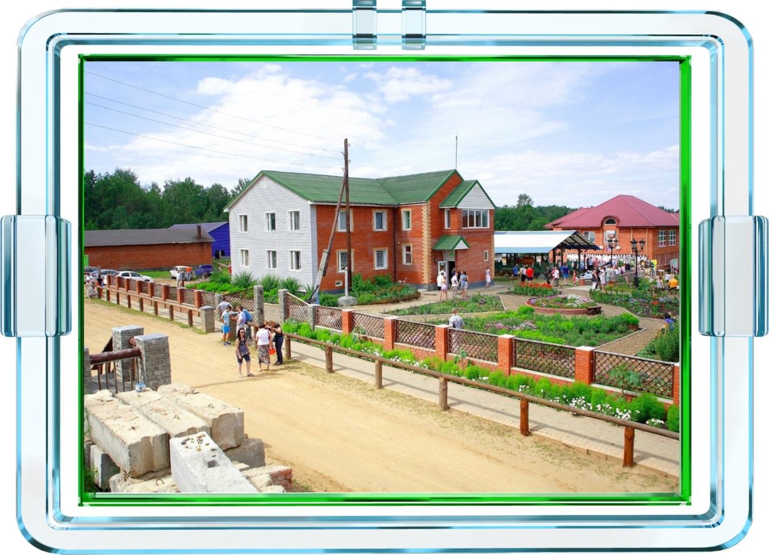

- Help people who have no fixed abode.

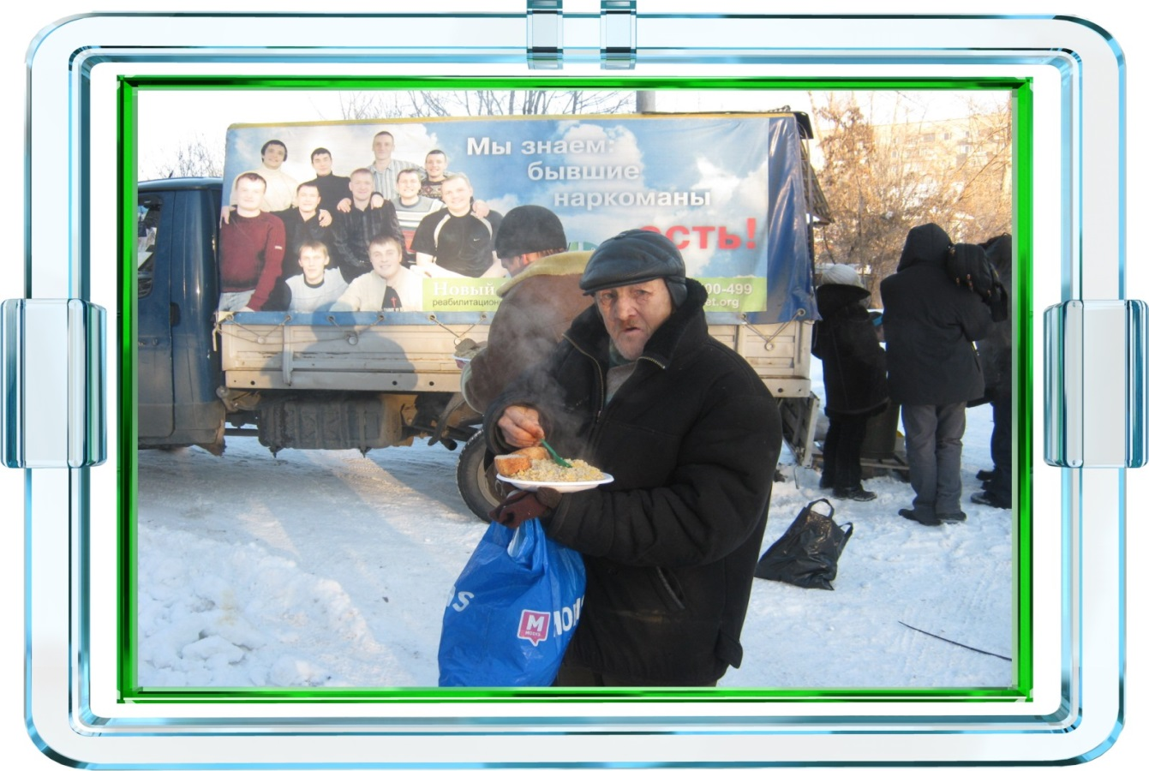

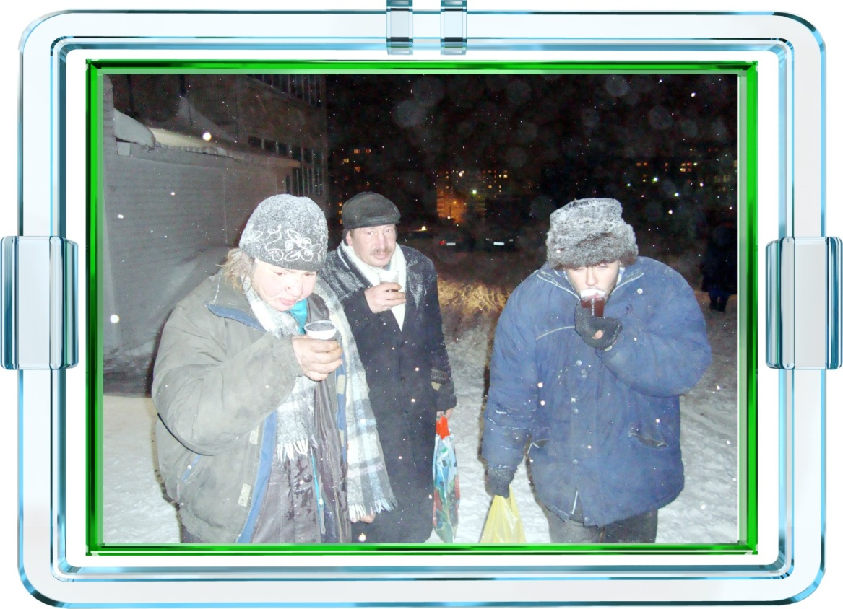

- Assistance for low income families.

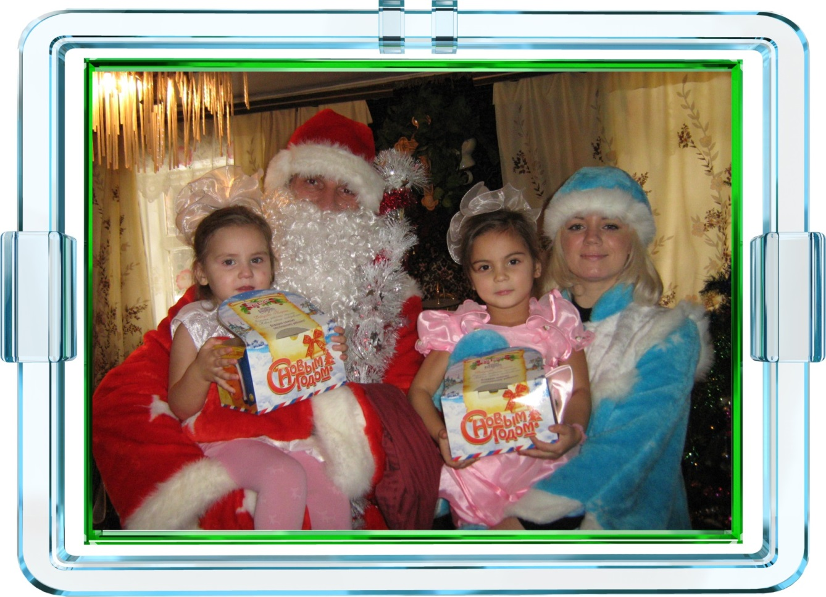
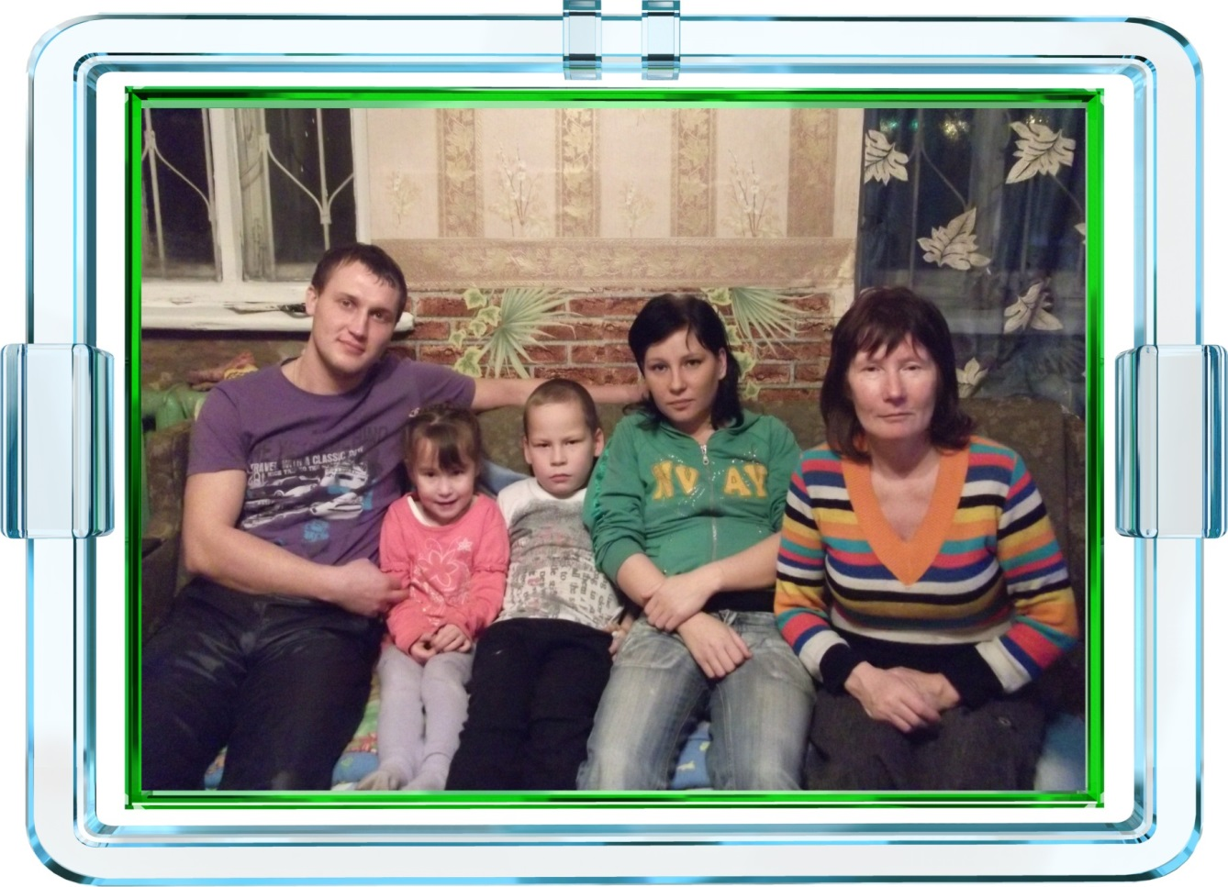
- Assistance to people released from places of imprisonment.
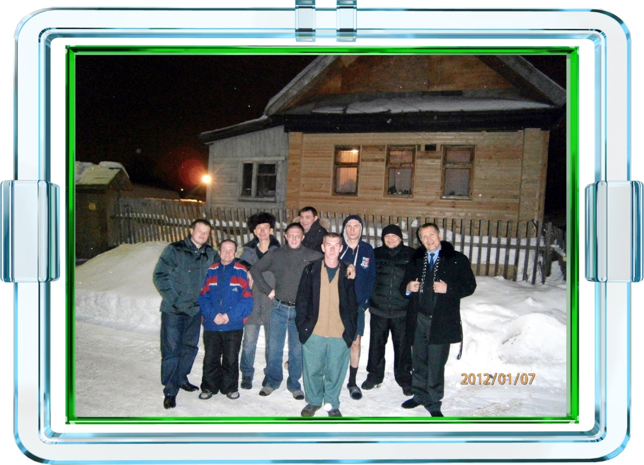
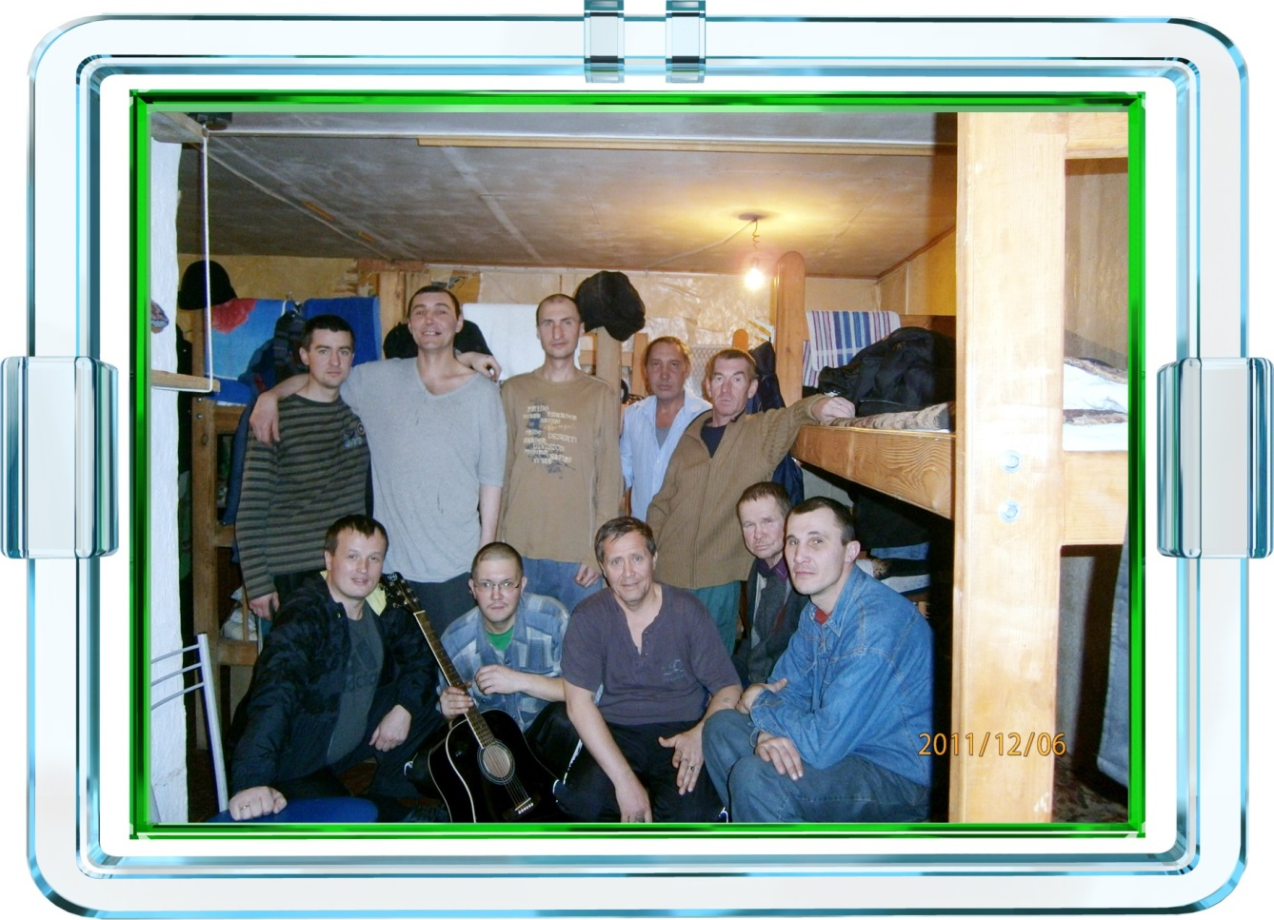
- Children's Center

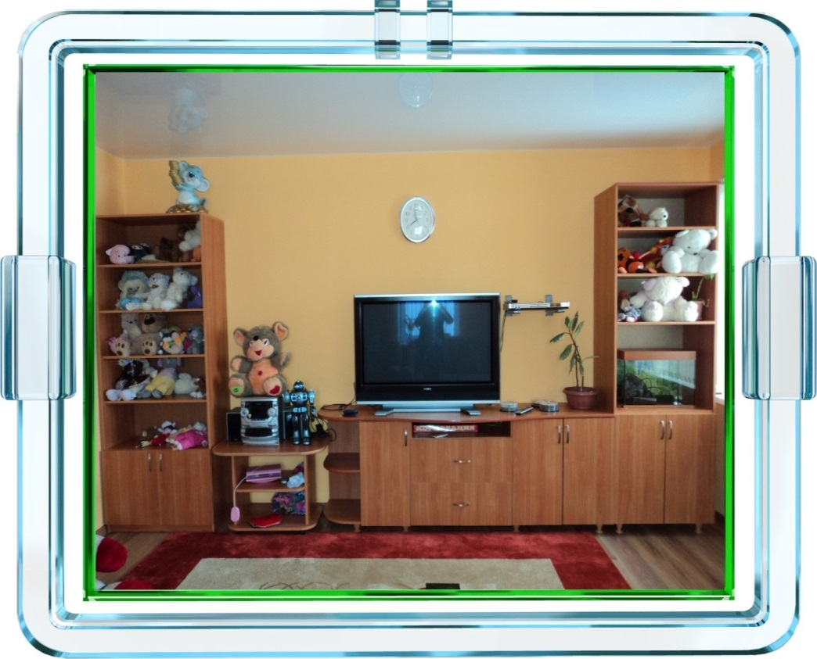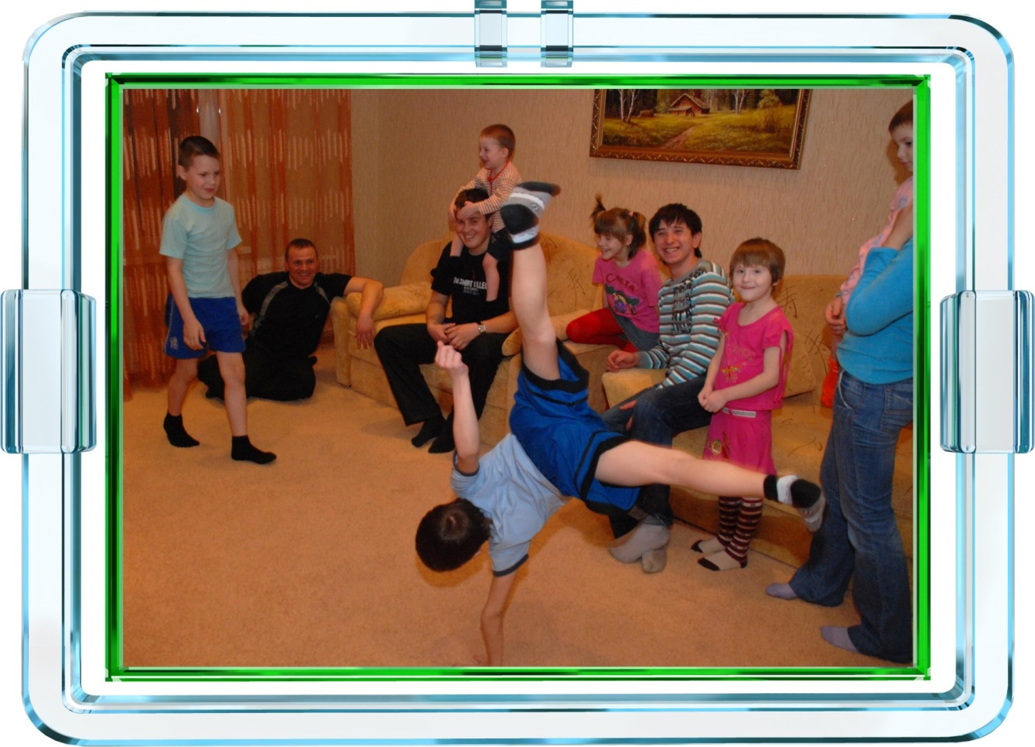

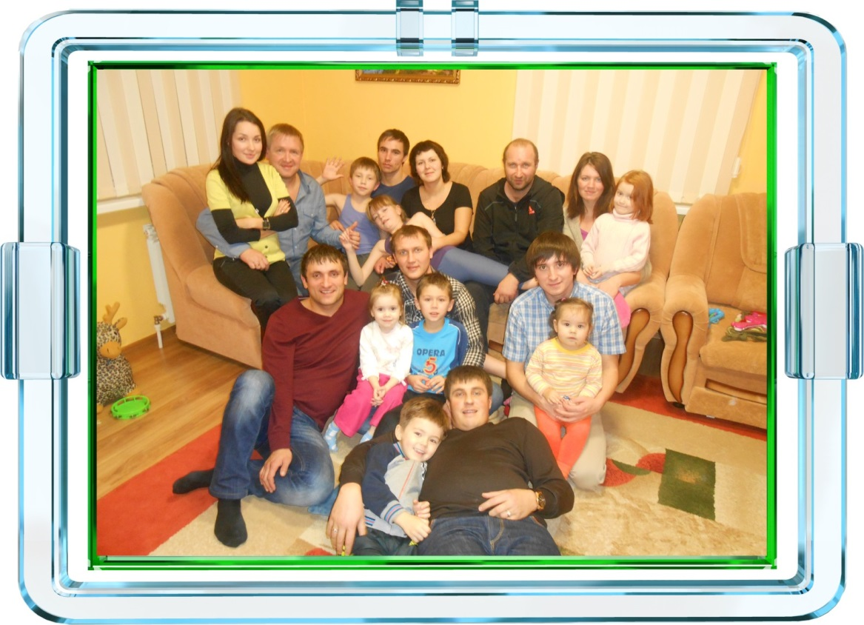
- Prevention of drug addiction.

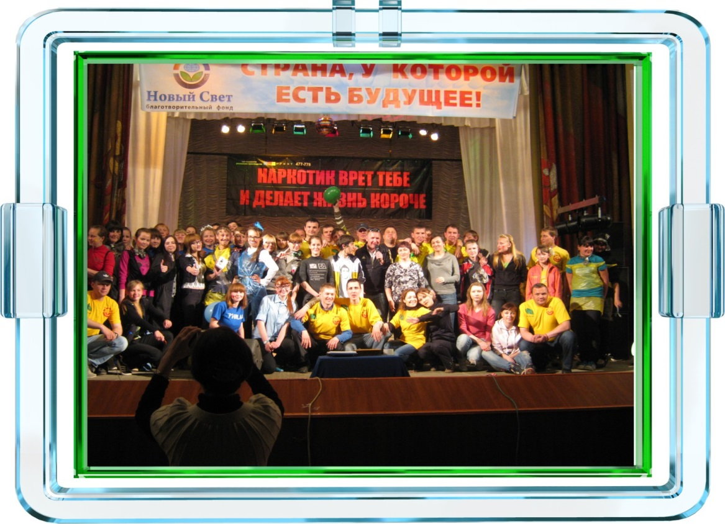
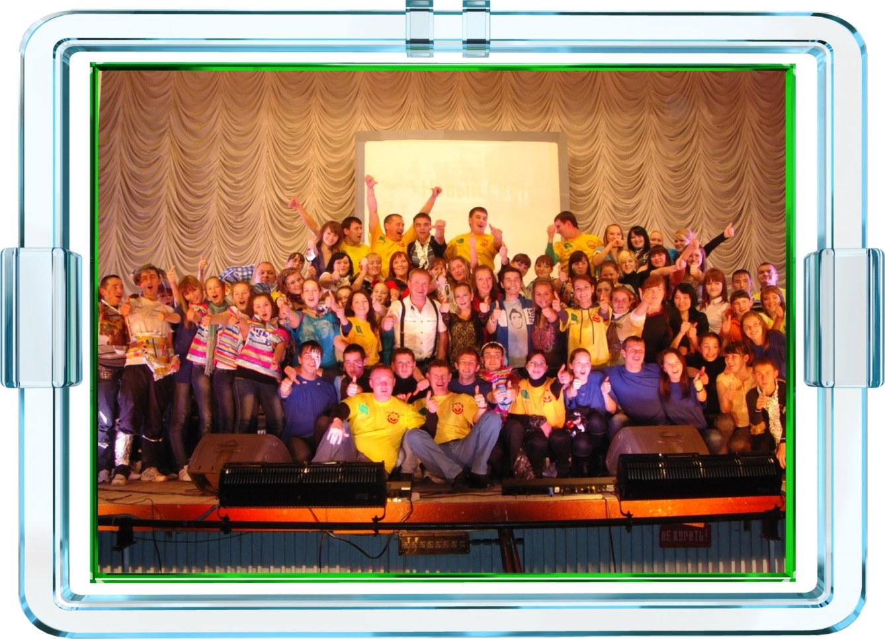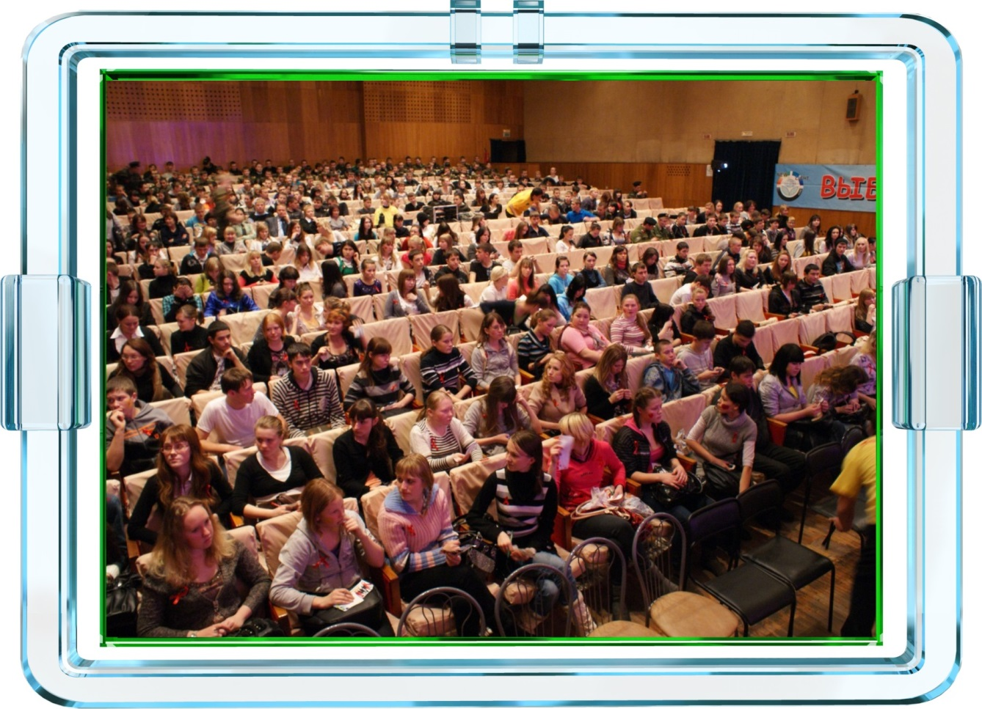
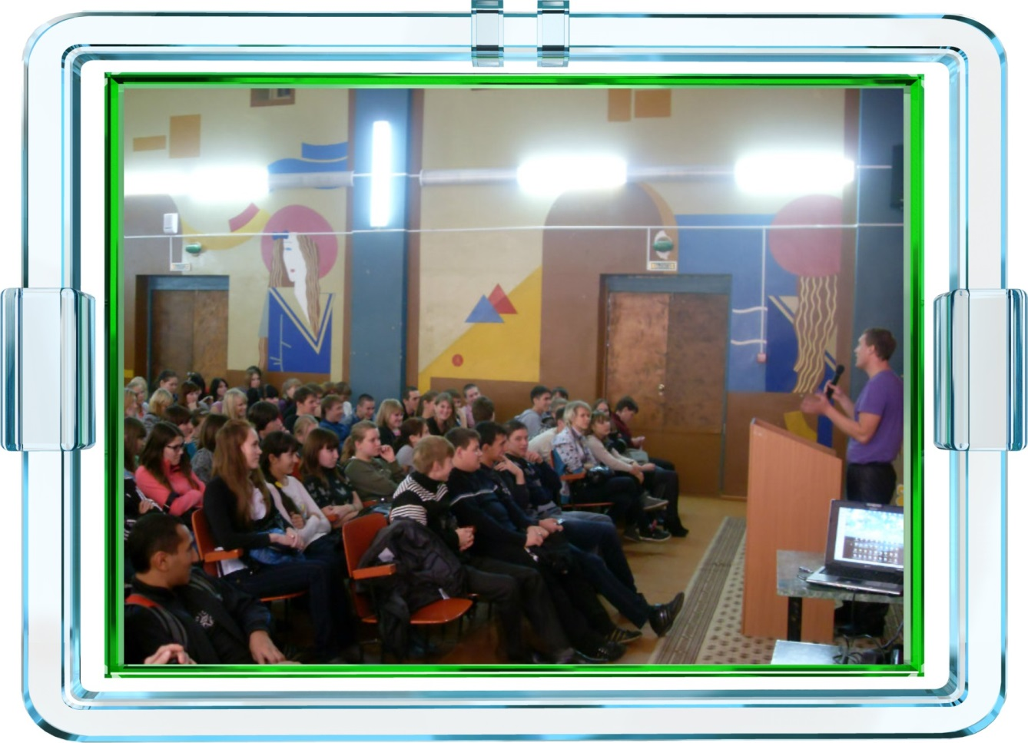

- Assistance for the disabled.
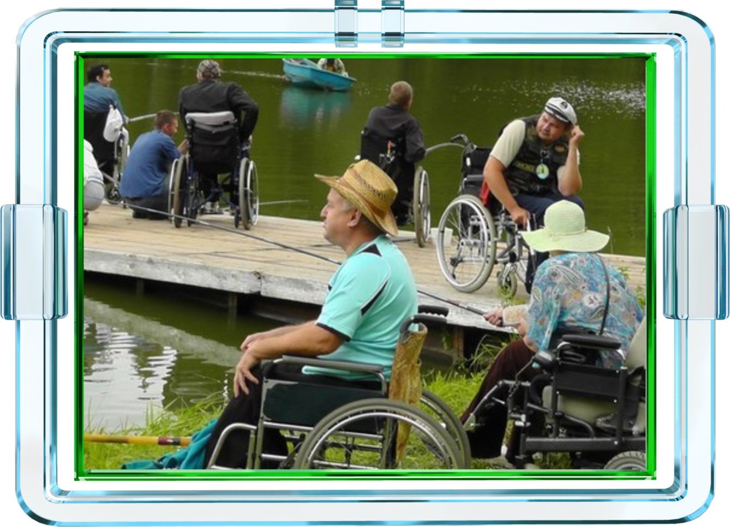
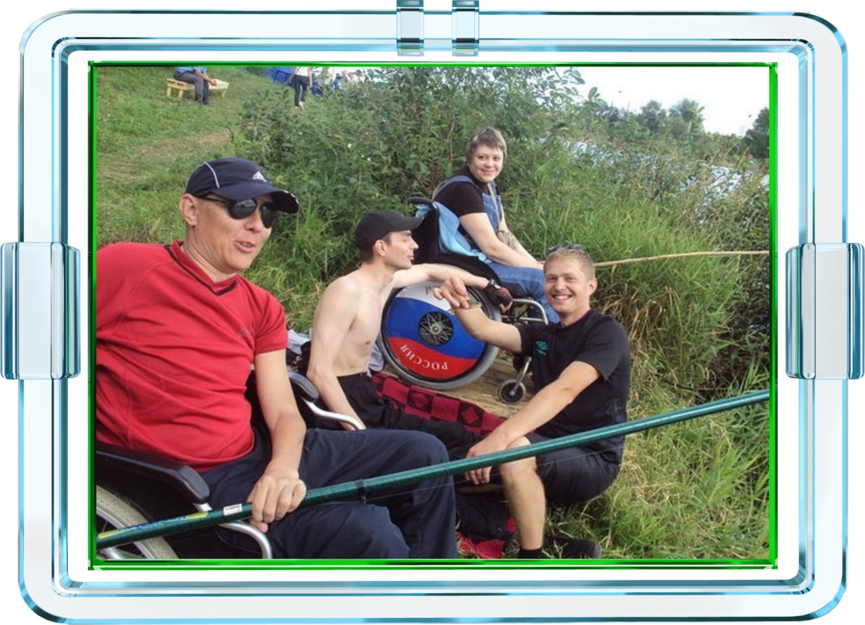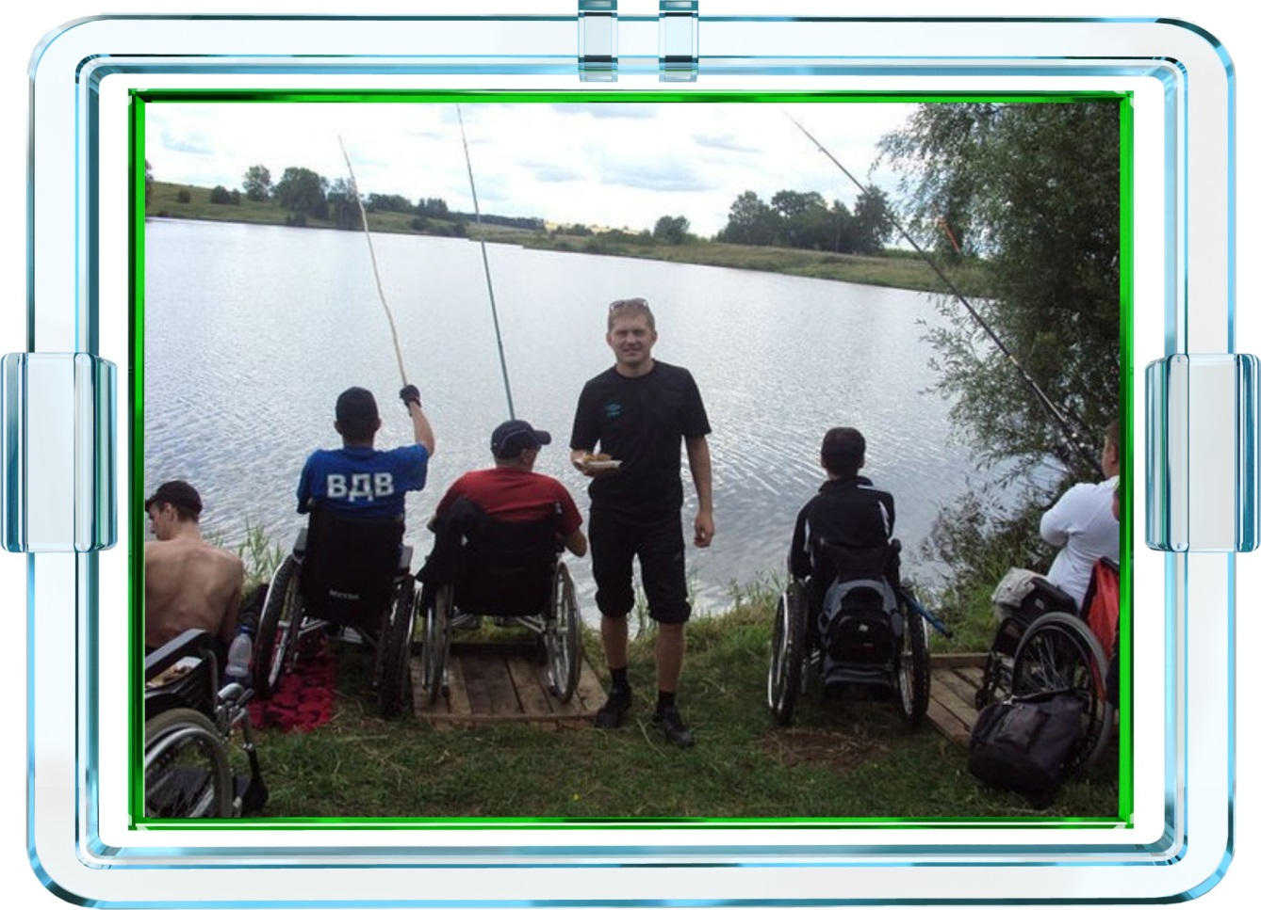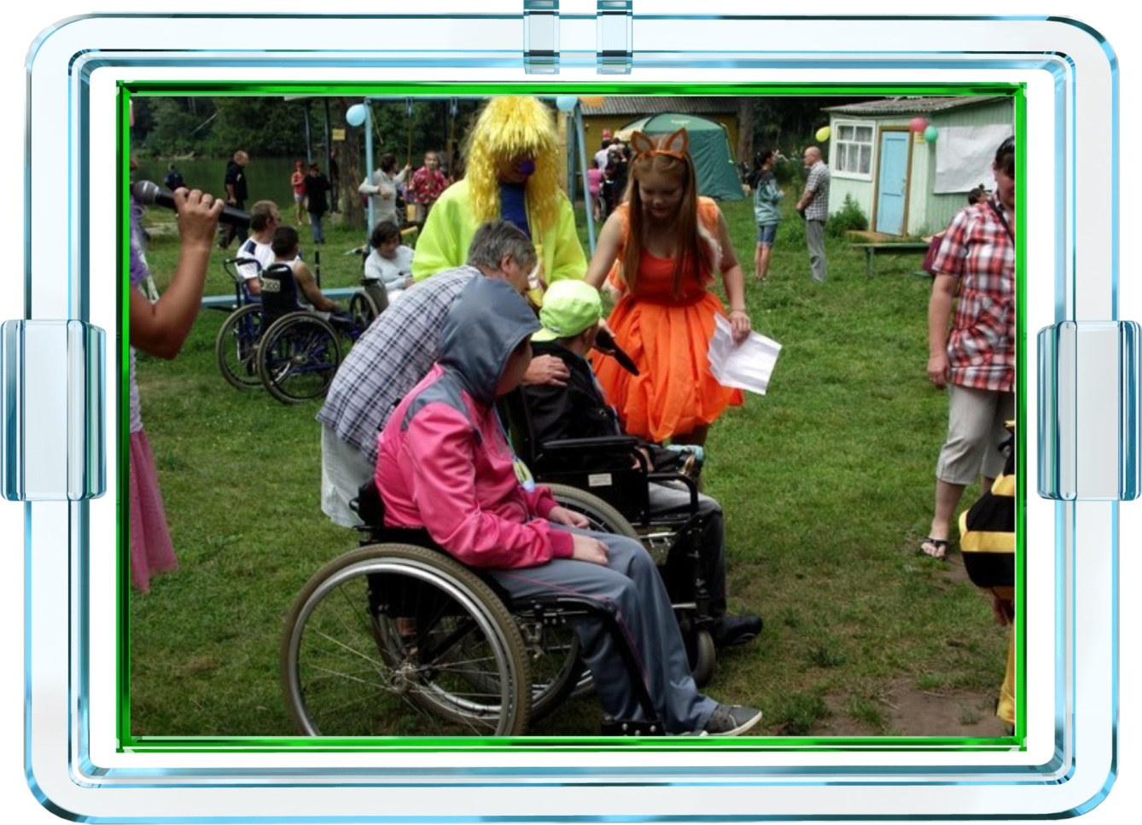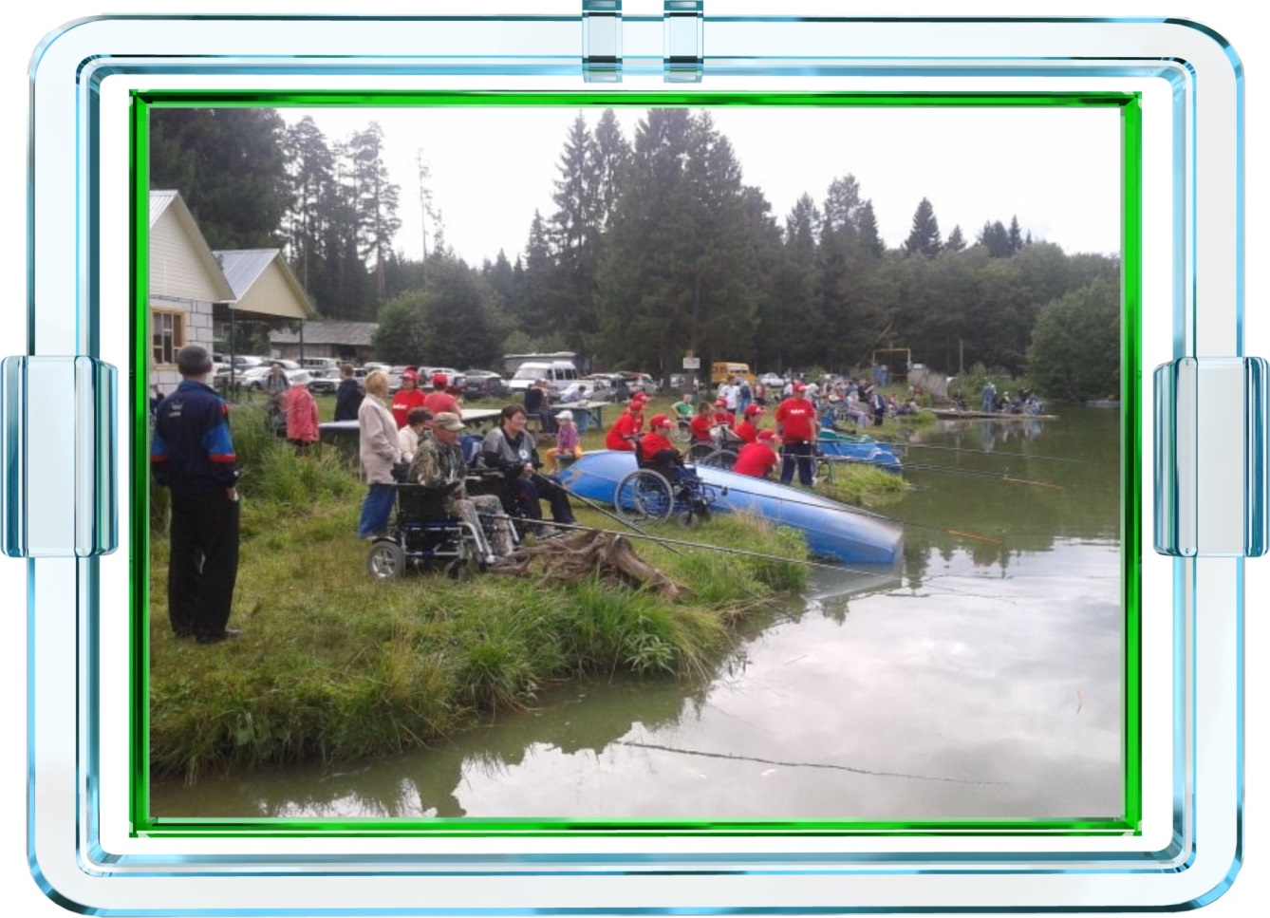
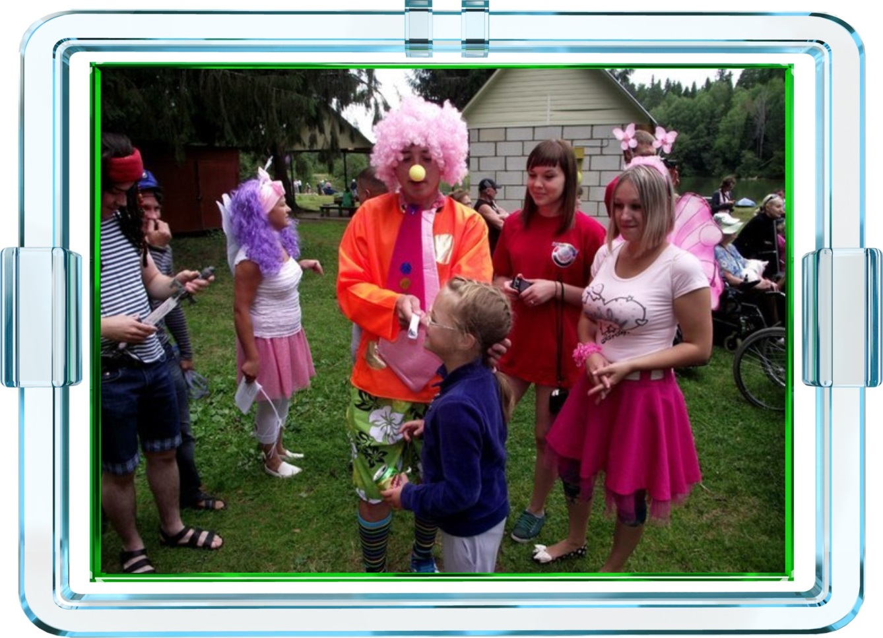
I think that “New Light” is very important organisation for all the Russia and for me.
This is charity organization to make a big contribution for many people, I and all members organisation «New Light» want to make a difference for Russia because many people needs in the help and «New Light» ready helps all if they want it.

