**TEACHER’S NOTES**

**At the movies**

Level: Pre-intermediate and above

Target age: Teenage and above

Time needed: 45 minutes plus recording time

Aim: For students to produce a short video / audio of their own movie review.

Materials: Digital camera or mobile phone / mp3 recorder (e.g. iPod)

(e.g. *a scene / to shoot / the soundtrack / a box office hit).*

1. There were three adjectives used in the review that mean very good. Can students remember what they were? Scan to find them: incredible / excellent / fantastic. Students then do the matching task in part 4.

***Answers:***

Preparation

Before the lesson you need to download a movie review from the Internet. YouTube has plenty. Choose one that is suitable for your students. To search, write in the name of a movie and add + movie review. For example, Michael Clayton + movie review.

Lead in to the topic

|  |  |
| --- | --- |
| fascinating | interesting |
| weird | strange |
| hilarious | funny |
| fantastic | good |
| terrible | bad |
| terrifying | frightening / scary |
| brilliant | clever |
| gripping | exciting |
| stunning | beautiful |

Give each student a copy of the worksheet and get them to ask and answer the questions in part 1. This is a speaking activity, so no writing.

After a while, ask a few students to give their opinion to the class.

Vocabulary

1. Elicit what a film review is (a personal opinion of a film) and who might read one (someone who may be interested in seeing the film).
2. Ask students to read the review in part 2 and ask if they think it's a good review for someone who wants to see the film for the first time. Students should notice that the review tells

us who lives and who dies. This is called a spoiler as it spoils the film for the viewer and is something that should be avoided in a good review.

1. What kind of film is the review about? Elicit that it's both a love story, a romance, and a disaster film. Students then solve the anagrams in part 3 of the different film genres.
2. Students read again and underline all the film vocabulary they can find in the review (Directed by

/ It stars / special effects / actors / characters / story / big screen). Highlight the words which are nouns (e.g. actor / director / star) which can also be verbs and vice versa. Elicit or give any other vocabulary you think is appropriate for your students

Note: You can't always add very in front of the stronger adjectives but you can always add really: X very excellent P really excellent

Preparing to record

1. Tell students they are going to make a review

- but not a written review, a recorded one. This can either be filmed as a video, or just an audio.

1. Ask students to watch the movie review you have chosen. Their first task is to decide how positive the review is.
2. For the second task students look at the chart in part 5. They listen again and put a tick (P) in the B column if the things in the A column are mentioned. They don't have

to write anything - only put a tick. Make sure students aren't writing in column C. After listening, students compare their charts and answers can be checked with the class. If students heard the name of the movie, etc. that's good, but it's not important. See if the students heard any adjectives used. Did they like the review?

1. Students are now ready to consider their own

review. They should work in pairs and together fill in the information in column C. This should only be in note form. They should not include a spoiler, or give too much of the story away! They should use some of the movie vocabulary

**TEACHER’S NOTES**

**At the movies**

as well as some extreme adjectives.

1. Using the notes, each student practises talking about the movie. They should do this enough times until they are confident about being recorded. Ideally, students should aim for one minute. It can be longer of course but a shorter review is more interesting than a longer one to listen to.
2. After the reviews have been recorded the videos can be uploaded to YouTube.

They can then be watched by all the students in

another lesson. The videos can also be watched by other students around the world!

1. Audio recordings can also be listened to by all the students in another lesson. If your school has a website, perhaps you can upload the recordings there so that other students can listen to the reviews too.

WORKSHEET

**At the movies**

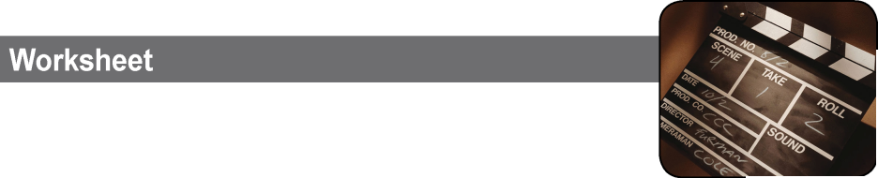

**Part 1**

Who is your favourite actor?

Which is your favourite film?

How often do you watch ... a film on TV? / ... a DVD or video of a film? / ... a film at the cinema?

**Part 2**

Titanic is simply one of the best films ever made by James Cameron it tells the story of the passen first, and last, voyage of the Titanic. It stars as Rose, a first-class passenger, and Leonardo Di who’s travelling third-class. They meet, fall in boat hits an iceberg. The special effects are inc feels like the biggest ship ever built is sinking including Kathy Bates, are excellent. The film is long but it’s a gripping story with interesting c time passes quickly. Like many of the first-class survives the disaster - the film is her memory of Jack dies in the icy water. I really recommend th fantastic - just make sure you watch it on the bi at home!

. Directed gers on the Kate Winslet Caprio as Jack, love, and then the redible, it really . All the actors, over three hours haracters and the passengers Rose the voyage - but is film - it’s g screen and not

**Part 3**

**Identify the different kinds of films. The first one is done for you.**

**Part 4**

**Match the adjectives. For example, fantastic means very good.**

rohrro

htrrliel

vuedantre

tedevicte

cesince confiti

nimatinoa

naicot

icumals

**Part 5**

fascinating weird hilarious fantastic terrible terrifying brilliant gripping stunning

bad

beautiful

exciting

frightening / scary

funny

good

interesting

strange

clever

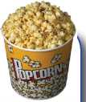

|  |  |  |
| --- | --- | --- |
| A | B | C |
| name of movie |  |  |
| name of director |  |  |
| actors’ names |  |  |
| type of movie |  |  |
| plot (story) |  |  |
| spoiler |  |  |
| recommendation |  |  |